Abstract
Web-based programs that focus on values, a core process within acceptance and commitment therapy (ACT), may be a promising approach to cultivate positive psychosocial adjustment among undergraduates. The current study tested the usability, acceptability, and receptivity of the Living Your Values (LYV) program, a single-session, web-delivered, self-guided values intervention for undergraduates and its utility to promote valued-living and psychological well-being. In an undergraduate sample (N = 133), while the LVY program was deemed moderately usable, acceptability and receptivity findings were more attenuated. At follow-up (n = 98), a significant pre-intervention to follow-up increase in valued-living was evidenced both overall and for leisure/recreation/community/citizenship values. No significant changes in psychological well-being were demonstrated. Further program development considerations are discussed.

Keywords: Acceptance and Commitment Therapy; Values; Web-based; College students

A Web-Based Self-Guided Program to Promote Valued-Living in College Students: A Pilot Study
Stemming from early psychological research (Feather, 1982; Hayes, Strosahl, & Wilson, 1999, 2012; Rokeach, 1973, 1979; Schwartz, 1992, 1994), interventions focusing on values – clarifying what one finds personally meaningful and promoting meaningful action – have demonstrated benefits for numerous populations, including undergraduates (e.g., Chase, Houmanfar, Hayes, Ward, Vilardaga, & Follette, 2013; Crocker, Niiya, & Mischkowski, 2008). By providing a framework for guiding in-the-moment decisions, values facilitate engagement with meaningful action, thus influencing long-term behavior (Scheier et al., 2006). They provide a sense of direction, meaning, and purpose in life, which is considered a part of authentic happiness and optimal functioning (Bronk, 2013). Value-consistent living also has evidenced a strong correlation with greater psychological well-being (Ciarrochi, Fisher, & Lane, 2011), which consists of both “feeling good” and effectively functioning (e.g., having a sense of meaning, pursuing valuable goals). Well-being can serve protective functions for undergraduates (Pritchard, Wilson, & Yamnitz, 2007; Ramos-Sánchez & Nichols, 2007), and relates to numerous beneficial functions (e.g., enhancing cognitive functioning, health, and relationships; Huppert, 2009).
Although few values-based interventions have been designed for undergraduates, they have targeted specific value domains such as academics (Chase et al., 2013) or relationships (Crocker et al., 2008). To date, no program – especially in a brief and easily accessible format – has been developed allowing students to reflect on and engage with their values at large. Therefore, the current study aimed to assist undergraduates in clarifying their values and engaging in personally-relevant value-consistent behavior. Specifically, it examined the usability and acceptability of a single-session self-guided web-based values program, students’ receptivity to the program, and the program’s effectiveness in promoting valued-living and psychological well-being.
Values and Personal Relevance
Values refer to qualities of actions that can be instantiated but never fully obtained or achieved (Hayes, Luoma, Bond, Masuda, & Lillis, 2006). They reflect how one acts, guiding moment-to-moment choices, and are considered intrinsically reinforcing: As larger patterns of value-consistent behavior develop, direction, meaning and purpose can emerge. Values also are freely chosen and individually determined. Some commonly utilized values-focused interventions have included didactic exercises and metaphors (e.g., the values compass) to define values, differentiate between values and goals, and depict values as a life direction (e.g., Biglan, Hayes, & Pistorello, 2008; Chase et al., 2013; Levin, Pistorello, Seeley, & Hayes, 2014). Other techniques have involved values-sorting tasks and experiential exercises (e.g., imagining positive comments close others would say about them; Harris, 2009) to promote value identification/clarification, the relative importance of different values, and comparisons between current and ideal ways of living (e.g., Harris, 2009; Levin, Pistorello, Seeley, et al., 2014; Wilson & Murrell, 2004). Additionally, values-affirmation writing exercises encourage reflection on personally-relevant values (e.g., Cohen, Garcia, Apfel, & Master, 2006; Schmeichel & Vohs, 2009; Shnabel, Purdie-Vaughns, Cook, Garcia, & Cohen, 2013) and promote values-based goal-setting (e.g., Chase et al., 2013; Levin, Pistorello, Seeley, et al., 2014).
Regarding valued-living, better outcomes have been associated with more personally-relevant values. For example, Lydon and Zanna (1990) found personal value relevancy was positively associated with undergraduates’ commitment to personal projects when faced with high adversity. Similarly, Oishi, Diener, Suh, and Lucas (1999) found that satisfaction in valued life domains (versus non-valued domains) was more strongly related to global life satisfaction. These findings highlight the importance of fostering connections to personally-relevant values.
Empirical findings support the use of values-based interventions with undergraduates to promote various beneficial outcomes (e.g., Miyake, Kost-Smith, Finkelstein, Pollock, Cohen, & Ito, 2010; Shnabel et al., 2013). For example, Crocker et al. (2008) found undergraduates experienced increased other-directed feelings (e.g., love) after writing about a personally-important value (versus an unimportant value). Further, Chase et al. (2013) found the values training portion of a web-based goal-setting program (i.e., didactics via media clips, metaphors describing values and differentiating values from goals, and writing about academic values) predicted increased grade point average (GPA). These findings highlight the use of values-focused interventions to foster positive undergraduate outcomes in specific domains. Additionally, Chase et al.’s findings support the use of autonomous web-based programs as a powerful way to increase dissemination of values-focused interventions on college campuses.
Web-Based Interventions for Undergraduates
Consistent with undergraduates’ growing independence as they transition to young adulthood, college-aged students may prefer self-guided programs (Rickwood & Bradford, 2012) such as web-based interventions. Various factors have contributed to the increased interest in delivering web-based psychological services, including cost-effectiveness, temporal efficiency and convenience, flexibility of use, and anonymity (for a review, see Davies, Morriss, & Glazebrook, 2014). Further, undergraduates’ beliefs and attitudes (N = 13,105) revealed a preference for independently handling mental health-related issues (Eisenberg, Speer, & Hunt, 2012). These reports highlight the importance of exploring options to deliver undergraduate services through easily accessible, brief, and independently utilizable mediums. Empirical evidence has supported web-based interventions’ effectiveness among undergraduates to improve relationships (Braithwaite & Fincham, 2009), mental health, and stress (for a review, see Davies et al., 2014). Furthermore, single-session web programs have demonstrated utility in fostering undergraduate academic success (Chase et al., 2013; Morisano, Hirsh, Peterson, Pihl, & Shore, 2010).
A few studies have shown promise regarding the effectiveness of brief, self-guided web programs for undergraduates with a values component (i.e., Chase et al., 2013; Levin, Pistorello, Seeley, et al., 2014; Levin, Hayes, Pistorello, & Seeley, 2016; Räsänen, Lappalainen, Muotka, Tolvanen, & Lappalainen, 2016). Levin, Pistorello, Seeley, et al. (2014) demonstrated initial effectiveness of a web-based acceptance and commitment therapy (ACT; Hayes et al., 1999, 2012) program to prevent mental health problems and promote valued-living in undergraduates. This study randomly assigned non-treatment-seeking undergraduates to an ACT or waitlist condition. The ACT condition comprised of values and acceptance components in two lessons. Lesson one educated participants on values and goals via a multimedia animation, didactics, subsequent examples, interactive tasks, and quizzes on values; participants then explored and clarified their values (e.g., values-sorting and values-affirmation journaling exercises) and set values-based goals (e.g., didactics on values-based goals and a goal-setting worksheet). Lesson two helped students manage valued-living barriers through emphasizing acceptance of distressing internal experiences. Usage and usability data revealed this program was acceptable and feasible among college freshman, and students spent adequate time completing both lessons (M = 81.98 minutes, SD = 22.68 minutes). Additionally, the ACT condition evidenced greater education value success at post-intervention than the waitlist condition.
Although these web-delivered values programs have shown promise for promoting undergraduate outcomes, these studies measured a limited set of values (educational and relationships) versus an encompassing set of value domains (e.g., family relationships, friendships, leisure, health, and spirituality). As noted above, personally-relevant value connections are associated with better outcomes. Thus, providing undergraduates the opportunity to explore a range of values may allow greater flexibility to identify, focus on, and affirm personally-relevant life domains, suggesting implications for broadening program applicability.
Current Study
As noted above, empirical evidence suggests values-based intervention strategies could enhance various undergraduate life domains (e.g., relationships, health, well-being, and academic performance). While most values-focused interventions are part of larger treatment packages involving multiple therapeutic processes targeting symptom reduction (for a review, see Levin, Hildebrandt, Lillis, & Hayes, 2012), few studies have focused solely on values and promoting valued-living in and of itself, and none have examined a values-specific intervention’s impact on undergraduate well-being. Furthermore, using web-delivered interventions to reach and engage students has many advantages. As such, this study aimed to build upon previous findings in several ways. First, considering the importance of value relevancy, the program enabled students to select and focus on personally-relevant values (versus targeting specific values). Second, the program was a single, 60-90 minute session. In addition to time- and cost-effectiveness, brief, single-session programs hold unique advantages relative to longer, multi-session programs by minimizing participation burden, thereby promoting program engagement (Stice, Shaw, Bohon, Marti, & Rohde, 2009). Furthermore, consistent with commonplace undergraduate preferences (Eisenberg et al., 2012; Rickwood & Bradford, 2012), this study capitalized on advantages of self-guided web-delivered interventions.
The current study’s first aim was to design a web-based single-session values-focused program (Living Your Values or LYV) for undergraduates, which was hypothesized to demonstrate high usability (e.g., easy to navigate), acceptability (i.e., how much participants liked the program), and receptivity (i.e., helpfulness, likelihood of referring a friend, interest in future values-related work). Further, participants were predicted to show significant improvements in values-consistent living and psychological well-being from pre-program to the 4-week follow-up.
Method
Participants
Data was collected at a medium-sized Catholic university in the northeast U.S. with a student body that is primarily female (60%), ethnically diverse (52% White), and from at-risk populations (e.g., 36% first-generation; 41% Pell-grant recipients). Eligible participants were at least 18-years-old undergraduate students, English-speaking, enrolled at the university where the study took place, and had computer and Internet access. Although 163 students consented to participate, 26 participants’ data were excluded due to premature study termination (i.e., prior to completing pre-measures, the program, or post-measures). The participant flow diagram provides a detailed outline of dropout rates as well as rates and reasons for exclusion from analysis at each study stage (see Figure 1).
The final sample consisted of 137 students (86.9% female), including 51 freshman, 35 sophomores, 18 juniors, 32 seniors, and one fifth-year post-baccalaureate student. Participants’ mean age was 20.22 (SD = 4.35). Most participants self-identified as White (53.3%), followed by Black/African-American (18.2%), other (13.9%), multiracial (7.3%), Asian (5.8%), and American Indian/Alaskan Native (1.5%); 21.2% of participants identified as Hispanic. Most participants reported living on campus with roommates (51.1%) or off-campus with family (33.8%) and to be single (50.4%) or dating in a monogamous relationship (41.4%). Additionally, 47.4% of participants reported a “sufficient” household income, whereas 31.6% reported an “insufficient” household income. The mean GPA of non-first-semester freshmen participants (n = 98) was 3.27 (SD = .49).
Measures
In addition to demographics questions and a program satisfaction and feedback questionnaire designed by the study authors, participants completed the following measures:
Personal Values Questionnaire (PVQ). The PVQ (Ciarrochi, Blackledge, & Heaven, 2006) contains a series of 10-item subscales which evaluate facets of values across nine life domains: family relationships, friendships/social relationships, couples/romantic relationships, work/career, education-schooling/personal growth and development, recreation/leisure/sport, spirituality/religion, community/citizenship, and health/physical well-being. To maximize a balance between program engagement and scope across the nine PVQ domains, a modified PVQ was used, which collapsed these nine domains into five: (a) family relationships; (b) friendships/romantic relationships; (c) education/work; (d) physical health/physical well-being/spirituality; (e) leisure/recreation/community/citizenship. Previous research has modified the PVQ domains at times to reduce the number of subscales for assessment burden reasons, finding the measure is still reliable and sensitive to detecting intervention effects (e.g., Levin, Pistorello, Seeley, et al., 2014). Participants provided brief written descriptions of their values within each value domain and indicated their success level in value-consistent living within each domain for past four weeks on a 5-point Likert scale from 1 (0-20% successful) to 5 (81-100% successful). Previous studies support the PVQ’s construct validity in undergraduate samples with respect to value success scores (Ciarrochi et al., 2006; Ferssizidis, Adams, Kashdan, Plummer, Mishra, & Ciarrochi, 2010).
Ryff’s Psychological Well-Being Scale – 42-Item Version (PWB). The PWB (Ryff, Seeman, & Weinstein, 2013; Ryff, 1989) is a 42-item self-report questionnaire yielding six subscale scores that capture core psychological well-being dimensions: autonomy, self-acceptance, life purpose, environmental mastery, positive relationships, and personal growth. Participants rate their agreement level with statements on a 6-point Likert scale, ranging from 1 (Strongly Disagree) to 6 (Strongly Agree). Higher scores represent greater domain-specific psychological well-being. In a nationwide adult sample, the PWB demonstrated acceptable internal consistency for all subscales, ranging between .70 and .84 (Ryff et al., 2013). In the current study, PWB subscales demonstrated good internal consistency for self-acceptance (α = .82), autonomy (α = .77), positive relationships (α = .77), and life purpose (α = .73), acceptable internal consistency for personal growth (α = .67), and poor internal consistency for environmental mastery (α = .44).
System Usability Scale (SUS). The SUS (Brooke, 1996) is a 10-item self-report questionnaire evaluating program usability and acceptability using a 5-point Likert scale ranging from 1 (Strongly Disagree) to 5 (Strongly Agree). Total scores range between 0 and 100, with higher scores reflecting greater perceived usability; scores below 70 reflect usability issues that are cause for concern (Bangor, Kortum, & Miller, 2008). Cutoff scores are empirically-derived to identify below and above average usability ratings (Bangor et al., 2008; Sauro, 2011). SUS items load onto one latent factor with high internal consistency (α = .91), which discriminates between more and less usable programs (Bangor et al., 2008). The SUS demonstrated good internal consistency within the present study (α = .80).
Zuckerman-Kuhlman Personality Questionnaire - Form III Infrequency Subscale (ZKPQ-Form III Inf). The ZKPQ-Form III Inf (Zuckerman, Kuhlman, Joireman, Teta, & Kraft, 1993) subscale is not regarded as a scale, per se, but rather a 10-item self-report measure designed to detect task inattention. Total scores range between 0 and 10, and scores greater than three suggest questionable validity of their responses due to task inattention. In the current study, the ZKPQ-Form III inf was used as a methodological check of participants’ engagement in the online program, given the prevalence of attentional lapses and mind wandering in online learning environments (Szpunar, Moulton, & Schacter, 2013).
Study Design and Procedure
Following Institutional Review Board approval, undergraduates were recruited from psychology classes where instructors agreed to provide extra-credit compensation. At the onset of each semester, study recruiters made brief in-class announcements regarding general study information and distributed flyers with a link to the online consent form via Qualtrics, a secure online data collection and program development tool. Following consent, participants were directed to pre-measures in the following order: PWB and PVQ.
After completing pre-measures, students were introduced to the LYV program, a web-based self-guided values-focused program for undergraduates based on ACT concepts administered via Qualtrics. The LYV program’s design was based on a web-based values intervention developed for depressed and/or anxious patients (Dalrymple, Levin, Haeger, Walsh, Rosenstein, & Gaudiano, 2016), and was customized in the current study for undergraduates.
The LYV program included didactic and experiential exercises to help students identify and clarify their values and set values-based goals. To promote visual appeal and engagement, expandable text was embedded throughout the program, allowing participants to read less/more about each topic. Worksheets and exercises, case examples of hypothetical college students, metaphors, and a media clip were included to guide application of valued-living concepts throughout the program. Additionally, the program was individualized to participants such that their responses to values exercises were repeatedly presented as they completed the program. At the program’s conclusion, participants were provided instructions/information on setting values-based goals and encouraged to complete a daily value journaling exercise over the subsequent four weeks. Last, participants could print an overview of covered content and a summary of their exercise responses. See Table 1 for a brief description of LYV program components, objectives/purposes, and specific example exercises associated with them. See Figure 2 for a sample of screen-captured images from the LYV program.
Following program completion, participants completed post-measures on Qualtrics, including the SUS, program satisfaction and feedback questions, ZKPQ-Form III Inf, and demographics questions. Participants were compensated with a $5 gift card for their participation in Time 1 (i.e., pre-measures, LYV program, and post-measures).
Four weeks after completing post-measures, participants were emailed a link to the follow-up measures, which were administered in the following order: PWB, PVQ, and program satisfaction and feedback questions. They also were asked how frequently they completed the homework journaling exercise, how they implemented what they learned, and what aspects they found most and least helpful from the LYV program. For full completion of follow-up measures at Time 2, participants received extra credit in one eligible psychology course. Of note, in the current study, post-intervention and follow-up measures examined program usability, acceptability, and receptivity, and pre-intervention to follow-up analyses investigated changes in values-based action and psychological well-being.
Results
Preliminary Analyses
A series of initial analyses were performed to ensure data validity and integrity. First, missing values analyses were conducted for the primary measures. Participants with more than 40% missing data across pre- and post-measures or across pre-intervention and follow-up measures were excluded from the final sample; two participants met this criterion and their data were excluded from analysis.
Random/careless responding and task inattention were then investigated by examining whether participants had ZKPQ-Form III Inf scores greater than three, repeatedly marked the same response option within and across measures, and/or were consistently non-adherent during the program (i.e., not responding to any values-focused exercise). Participants were excluded from analysis if they met more than one of these conditions and/or met one of these conditions and demonstrated more than 25% missing data across pre- and post-measures; two participants were excluded. Additionally, one participant repeatedly marked the same response option across follow-up measures and had 26.7% missing data across pre-intervention and follow-up measures. This participant did not meet other data removal conditions and was therefore retained in post-intervention analyses, though was excluded from follow-up analyses. Mean imputations were subsequently implemented to handle remaining missing data.
Data analyses evaluated for univariate outliers using Z-scores (absolute values greater than 3.29) and boxplots of grouped differences between pre-intervention and follow-up. Following identification of potential univariate outliers, an iterative approach was implemented to test the impact of each data point on the results and normality assumption, which further informed decisions regarding removal of outliers from analyses. Although two participants had Z-score values greater than 3.29, the results remained stable for all analyses. Thus, 133 participants were retained in the program usability, acceptability, and receptivity analyses. Ninety-eight participants were retained in pre-intervention to follow-up analyses.
Data were then tested to ensure the respective paired-sample t-test assumptions were met; there were no violations. See Table 2 for means and standard deviations for this study’s included measures.
Program Flow and Usage
Some attrition was evidenced between assessment phases (see Figure 1). Most participants who initiated the study (n = 137) completed all study components at Time 1 (i.e., pre-measures, LYV program, and post-measures). While 28 participants discontinued the study after completing post-measures (n = 109), most participants who initiated Time 2 fully completed follow-up (n = 103).
Among study completers in the final dataset (n = 133), the average completion time for Time 1 was 84.39 minutes (SD = 58.34); the average completion time for Time 2 was 30.22 minutes (SD = 30.78).¹ On average, participants reported completing the values journal assignment 1.78 times per week (SD = 1.78) between post-intervention and follow-up; 26 participants denied ever completing the assignment.
Evidence for Program Usability, Acceptability, and Receptivity
Usability. The LYV program’s average usability rating (i.e., the degree to which participants found the program easy to use/navigate and satisfactory) was 74.78 (SD = 15.50), reflecting a good program rating per empirically-derived SUS anchor scores (Bangor et al., 2008). Sauro (2011) reported that across 500 studies, the average SUS score was 68. Although one technical difficulty was noted (“It made me redo the questions 3 times after I already answered”), when asked in an open-ended format what was most liked about the program, 22.0% of responses at post-intervention reflected program formatting and/or ease of use (e.g., “Website was easy to use even for a beginner;” “The format was easy to navigate and not too complicated”).
Acceptability. Concerning program acceptability, average ratings for each LYV section at post-intervention ranged from 4.17 to 4.83 (SD = .90 to 1.36), reflecting slightly like to moderately like ratings. Similarly, at follow-up, average likeability ratings ranged from 4.40 to 4.63 (SD = 1.04 to 1.18), except for the Values Journal Assignment (M = 3.84; SD = 1.51), which fell between slightly dislike and slightly like. No significant changes in program satisfaction were evidenced between post-intervention and follow-up (p > .05).
Participants were asked to indicate what aspects of the LYV Program they liked most/found most helpful. 49.5% of post-intervention responses were about program content, including the exercises, audio/video, and examples (e.g., “The thought provoking questions, pictures, and videos;” “I liked when we talked about my values and who inspired me”). 20.9% of post-intervention responses focused on self-reflection as a liked aspect, which increased to 55.6% of comments at follow-up (e.g., “I thought it was interesting to see which set of values I value the most in my life. It’s also nice to see which set I need to work on improving;” “I like that I was made to think about what I want out of my relationships”). See Table 3 for additional responses about most liked/helpful aspects at post-intervention and follow-up.
Concerning responses to open-ended questions about what was most disliked, at both post-intervention and follow-up, comments focused on the length (post: 36.7%; follow-up: 21.6%) and repetitiveness (post: 30.0%; follow-up: 12.2%). A few participants commented that the length and redundancy contributed to boredom or inattention (“It was very long and tedious. I found myself getting bored”). Most participants expressed preferences to complete the LYV program in two, 30-45 minutes sessions (62%) rather than one, 60-90 minute session (32%); 6% declined to report or noted alternative preferences regarding session frequency/length.
Receptivity. Program receptivity was assessed via examination of follow-up ratings of program helpfulness, likelihood of recommending the LYV program to a friend, and interest level regarding engagement in future values-based work. Participants’ average program rating fell in the somewhat helpful range (M = 4.91, SD = 1.39). On average, participants reported being somewhat likely to recommend the LYV program to a friend (M = 4.72, SD = 1.62) and being neither interested nor uninterested to learn more about their values or engage in further values-based exercises (M = 4.35, SD = 1.61).
Values-Based Action
Paired sample t-tests assessed value success changes. Consistent with expectations, overall PVQ value success scores (i.e., value-consistent living across PVQ domains) significantly increased from pre-intervention (M = 19.98, SD = 3.63) to follow-up (M = 20.73, SD = 3.41), t (97) = -2.29, p = .02; this reflects a small sized effect (Cohen’s d = .23). A significant increase in leisure/recreation/community/citizenship value success was also evidenced from pre-intervention (M = 3.59, SD = 1.22) to follow-up (M = 3.91, SD = 1.02), t (97) = -2.64, p = .01; this change’s effect size was small (Cohen’s d = .27). Examination of specific values-based domains participants selected to work on between post-intervention and follow-up showed the majority choosing health/self-care (n = 32), followed by relationship values (n = 26), recreation (n = 12), and education (n = 7). Additionally, at follow-up, participants reported moderate progress in working towards the values-based goal set during the LYV program (M = 2.95, SD = .97). Of the 93 participants who listed a goal at follow-up, only 10 participants reported not engaging in strategies toward their values-based goal.
Psychological Well-Being
Paired sample t-tests assessed pre-intervention to follow-up changes in psychological well-being (PWB). Contrary to expectations, no significant within-group effects were evidenced for any PWB domains (p > .05).
Discussion
The current study investigated the usability, acceptability, and receptivity of the LYV program, a single-session, self-guided, web-based values program, and its effectiveness to promote valued-living and psychological well-being among undergraduates. Only a few studies have examined the utility of web-based, values-focused interventions (based in ACT) for undergraduates (e.g., Chase et al., 2013; Levin, Pistorello, Seeley, et al., 2014). However, these studies targeted a circumscribed set of values. Further, while one prior study analyzed the impact of web-based ACT on undergraduates’ psychological well-being (Räsänen et al., 2016), that study’s pilot program focused on numerous ACT processes and included seven sessions, two of which were face-to-face meetings. To date, no studies have evaluated the utility of delivering a completely web-based, single-session, values-focused intervention allowing students to select and engage in values with personal relevance.
Consistent with previous research (Levin et al., 2016; Levin, Pistorello, Seeley, et al., 2014), the LYV program was deemed usable, demonstrating an above average self-reported usability rating and an 84% program completion rate. Further, almost half of the responses to an open-ended question about most liked/helpful aspects related to program content (e.g., exercises, examples, audio/video), and over half of responses at follow-up related to the program fostering self-reflection (see Table 3 for sample responses regarding liked/helpful aspects). These results suggest it is possible to develop an engaging, easy-to-use web-based program targeting values.
Concerning acceptability and receptivity findings, scores were lower than anticipated. Mean likeability ratings across program sections ranged from mild to moderate, and mean receptivity ratings generally were in the somewhat category (i.e., somewhat helpful; somewhat likely to recommend the LYV program to a friend). Factors that potentially attenuated acceptability and receptivity ratings could be the program length and redundancy, the two most commonly disliked LYV program aspects. Consistent with past studies highlighting brief interventions’ advantages to increase program engagement and reduce participation burden (Levin, Pistorello, Seeley, et al., 2014; Stice et al., 2009), the LYV program was designed to be brief and delivered in a single, 60-90 minute session. That said, contrary to Levin et al.’s (2016) finding that approximately one-third of undergraduates rated a two-session web-based ACT program as too long, most present study participants expressed preferences toward completing the LYV program in two, 30-45 minute sessions versus one, 60-90 minute session. Further, repetitiveness/redundancy feedback primarily related to having to complete pre-post measures within the same sitting as the LYV program, rather than specific program aspects. Further, completing the PVQ was inherently redundant with LYV program content, time intensive, and may have been interpreted as part of the program versus an outcome measure. It is recommended that assessments be completely independent from the online intervention in future research to decrease program length and eliminate perceived redundancies. It is also possible that perceived weaknesses of program length/redundancy were influenced by the types of values-focused exercises in the LYV program (e.g., multiple writing exercises). In terms of future program development, congruent with research suggesting that including a variety of intervention activities helps cultivate long-term improvements in well-being (Deiner et al., 2017), it may be useful to intentionally vary the types of exercises to further increase brevity and engagement (e.g., incorporating less writing exercises and more brief multimedia animations).
In addition to program design, other factors could account for higher LYV program acceptability and receptivity ratings not being evidenced. Perhaps the construct of “usefulness” is contextual, and the LYV program’s broad and flexible scope contributed to participants variably defining/rating usefulness based on their chosen value(s) and program intentions. For example, whereas some participants’ usefulness comments reflected self-awareness and self-exploration (e.g., “I found mostly all of it to be helpful because it allowed me to truly reflect on myself and my life”), others reflected the program’s impact on goal-setting and behavior change (e.g., “I liked that the initial program really set out the groundwork for you to start working on your goals”). Asking participants to report on the value domain, values-based goals, and strategies used to obtain them can assist in understanding the program’s usefulness. Additionally, follow-up comments on usefulness indicated some participants wanted more accountability for engaging in values work following program completion (e.g., “I wish I could have been held more accountable for doing the journal”). Moving forward, some strategies to enhance program adherence and accountability after program completion could be to include an e-coach component or send participants automated check-in/feedback emails tailored to piped responses. Both strategies would require less skills and resources than face-to-face therapy (Andersson, 2010), and are consistent with a supportive accountability approach shown to improve adherence to web-based self-guided programs (Mohr, Cuijpers, & Lehman, 2011; Räsänen et al., 2016).
Though quantitative ratings about the LYV program’s acceptability and receptivity were lukewarm, findings were mixed related to the extent participants clarified their values. Whereas a significant pre- to follow-up increase in participation in valued actions was evidenced both overall and for leisure/recreation/community/citizenship values, value success did not significantly improve in other domains. It is possible this result was influenced by the present study’s measure of valued action (PVQ) being collapsed into five (instead of nine) value domains, which warrants further examination. Further, these findings are consistent with the top three value domains participants reportedly focused on (i.e., health/self-care, relationship, and recreation values), highlighting the importance of ensuring alignment between value-based measures and the personally-relevant values participants select. Extending a growing body of literature demonstrating web-based ACT can promote value success among undergraduates in the education domain (e.g., Levin et al., 2016; Levin, Pistorello, Seeley, et al., 2014), there is now evidence a single-session web-based ACT program solely targeting value processes can potentially promote value success in multiple domains among undergraduates.
Though participants selected a goal within a specific value domain at the end of the LYV program, out of the 93 participants who responded to the open-ended question at follow-up asking to state the value-based goal worked on, only 23.7% wrote a response consistent with their originally selected value. Interestingly, almost one-third of the sample (32.3%) wrote a response consistent with becoming happier or a better person, and another third wrote a response that was part of a different value domain, suggesting they had changed focus to a different domain during the 1-month follow-up period. On the one hand, the results suggest the importance of more accountability and reminders during the follow-up period to help participants stay on track related to the originally selected value. On the other hand, the results could support the importance of having the continued flexibility to select personally-relevant values. Since participants engaged in and arguably saw legitimate benefit of the values-focused exercises (i.e., students reported completing the values journal assignment on average 1.78 times per week despite it having no bearing on compensation), future research may want to examine more closely the reasons participants change their values-based goals after engaging in a values-based program (with the hope that the change in domain would be in response to wanting to live accordingly with their values).
Contrary to predictions, no significant changes in psychological well-being were evidenced from pre-intervention to follow-up. Several factors may account for this finding. First, many participants completed follow-up near the end of the semester, suggesting end-of-semester responsibilities and pressures may have curbed psychological well-being ratings. Thus, the importance of examining/controlling for potential end-of-semester effects on psychological well-being in future studies is indicated. Another possibility is that a 60-90 minute self-guided program was not powerful enough to impact a gross psychological well-being measure, especially since the LYV program encouraged a focus on a single values-based goal (versus goals in multiple valued domains) during the follow-up period. Thus, the intervention dose may not have been strong enough to impact psychological well-being. While Räsänen et al. (2016) demonstrated web-based ACT’s positive impact on undergraduates’ psychological well-being, it is unclear which aspects of that seven-session pilot program influenced psychological well-being (e.g., number of sessions, face-to-face components, values and/or other ACT processes). In effort to further develop a web-based program that enhances psychological well-being and concurrently minimizes participation burden, it is recommended that the intervention dose (e.g., number and length of sessions) and intervention processes (e.g., values in addition to other ACT processes, such as acceptance and contact with the present moment) be adjusted and examined in future research.
It is also of note that students reported improvements in values-consistent living and no changes in psychological well-being at follow-up, which could be accounted for by various factors. Congruent with literature suggesting that values processes (e.g., increases in values-based actions) precede decreases in suffering (Gloster et al., 2017), it may be that changes in value-consistent living also precede changes in psychological well-being. While the follow-up period may have been too brief to impact the PWB Scale, as this measure’s instructions are more general/global and potentially trait-based, it is also possible that an extended period of value-consistent behavioral practice (e.g., a period greater than four weeks) in multiple life domains is necessary to increase psychological well-being, which could be useful to examine in future research.
Limitations
Methodological weaknesses must be considered when interpreting the study findings. As this study lacked a comparison group, program efficacy could not be evaluated and alternate hypotheses for the findings (e.g., focused student priorities as a result of the semester progressing) warrants investigation. Additionally, though the current sample was racially/ethnically heterogeneous, it consisted of students from a single university and was mostly female (86.9%). Further, packaging the LYV program as a research project with a participation incentive for monetary and/or extra credit compensation could have inherently limited the ecological validity of findings. While this is a common limitation within undergraduate empirical research, this is a particularly important contextual limitation of the present study considering the program’s values-focused nature. That is, current study participants could reflect a subgroup of students who were uniquely orientated toward certain values (e.g., education) and/or driven by secondary outcomes (e.g., compensation) relative to the greater student body. As the influence of compensation on sample characteristics and program engagement is unknown, research comparing the LYV program with and without compensation would be beneficial. Additionally, it is unknown if and/or how outcomes were impacted by variability in how participants set their values-based goal during the LYV program (e.g., specificity, measurability, achievability, relevance, timing).
Alternatively, while the LYV program was developed to promote valued-living and psychological wellness in undergraduates, a perceived lack of purpose or need for the program could have attenuated program participation, engagement, or perceived usefulness. As such, the LYV program may need to be framed in the context of a problem (e.g., procrastination, perfectionism) or a goal (e.g., improving relationships, self-care, academic performance) to boost program receptivity. Additionally, the measures this study utilized to assess psychological well-being (PWB) and value success (PVQ) may have needed to be more specific to detect certain effects; alternatively, since PVQ responses from pre-intervention were presented to participants during the session summary of the LYV program, demand characteristics may have influenced participant PVQ responding at follow-up. Given the exclusion of measures focused on committed action, the need to investigate the LYV program’s effects with more specific behavioral outcome measures is warranted, especially to determine the program’s long-term effects. Follow-up with participants might suggest how the intervention may have impacted continued goal setting, value-based living, or participants’ ability to cope with life challenges.
Conclusion
While not all of the hypotheses in the current study were supported, the LYV program demonstrated an example of a usable, brief, and easily accessible standalone program that has the potential (after some revisions) to be implemented to promote valued-living in an undergraduate population. Consistent with trends evidenced in prior web-based undergraduate intervention studies (see Davies et al., 2014), the LYV program’s design may help address common barriers in the under-utilization of psychological wellness services among students, including stigma, time, cost, and access (Eisenberg et al., 2012). Alternatively, it could be integrated into the college orientation process, which could proactively facilitate students’ values-based connections at the start of college and help them navigate their college journey in a value-consistent manner. However, further program development and research first is needed to address this study’s lukewarm findings and limitations. Despite the limitations, this study’s initial findings could inform the continued development and research of the LYV or other brief, online values-based programs to promote various positive factors among undergraduates to help meet the needs of students and other relevant stakeholders on college campuses.

References
Andersson, G. (2010). The promise and pitfalls of the internet for cognitive behavioral therapy. BMC Medicine, 8, 82. doi:10.1186/1741-7015-8-82
Bangor, A., Kortum, P. T., & Miller, J. T. (2008). An empirical evaluation of the system usability scale. International Journal of Human-Computer Interaction, 24, 574-594.
Biglan, A., Hayes, S. C., & Pistorello, J. (2008). Acceptance and commitment: Implications for prevention science. Prevention Science, 9(3), 139–152. doi:10.1007/s11121-008-0099-4
Braithwaite, S. R., & Fincham, F. D. (2009). A randomized clinical trial of a computer based preventive intervention: Replication and extension of ePREP. Journal of Family Psychology, 23(1), 32–38. doi:10.1037/a0014061
Bronk, K. C. (2013). Purpose in life: A critical component of optimal youth development. New York, NY: Springer.
Brooke, J. (1996). SUS: A “quick and dirty” usability scale. In P. W. Jordan, B. Thomas, B. A. Weerdmeester, & I. L. McClelland (Eds.), Usability evaluation in industry (pp. 189–194). London, England: Taylor & Francis.
Chase, J. A., Houmanfar, R., Hayes, S. C., Ward, T. A., Vilardaga, J. P., & Follette, V. (2013). Values are not just goals: Online ACT-based values training adds to goal setting in improving undergraduate college student performance. Journal of Contextual Behavioral Science, 2(3), 79–84.
Ciarrochi, J., Blackledge, J. T., & Heaven, P. (2006, July). Initial validation of the Social Values Survey and Personal Values Questionnaire. Poster Presented at the Second World Conference on ACT, RFT, and Contextual Behavioural Science, London, England.
Ciarrochi, J., Fisher, D., & Lane, L. (2011). The link between value motives, value success, and well-being among people diagnosed with cancer. Psycho-Oncology, 20, 1184–1192. doi:10.1002/pon.1832
Cohen, G. L., Garcia, J., Apfel, N., & Master, A. (2006). Reducing the racial achievement gap: A social-psychological intervention. Science, 313, 1307–1310. doi:10.1126/science.1128317
Crocker, J., Niiya, Y., & Mischkowski, D. (2008). Why does writing about important values reduce defensiveness? Self-affirmation and the role of positive other-directed feelings. Psychological Science, 19, 740–747. doi:10.1111/j.1467-9280.2008.02150.x
Dalrymple, K., Levin, M. E., Haeger, J., Walsh, E., Rosenstein, L. & Gaudiano, B. (2016). Development of a brief, values-based online adjunctive intervention for depression and anxiety. Paper presented at the 14th annual World Conference of the Association for Contextual and Behavioral Sciences, Seattle, WA.
Davies, E. B., Morriss, R., & Glazebrook, C. (2014). Computer-delivered and web-based interventions to improve depression, anxiety, and psychological well-being of university students: A systematic review and meta-analysis. Journal of Medical Internet Research, 16(5), 18–39. doi:10.2196/jmir.3142
Diener, E., Heintzelman, S. J., Kushlev, K., Tay, L., Wirtz, D., Lutes, L. D., & Oishi, S. (2017). Findings all psychologists should know from the new science on subjective well-being. Canadian Psychology/Psychologie Canadienne, 58(2), 87–104. https://doi.org/10.1037/cap0000063
Eisenberg, D., Speer, N., & Hunt, J. B. (2012). Attitudes and beliefs about treatment among college students with untreated mental health problems. Psychiatric Services, 63, 711–713.
Feather, N. T. (1982). Expectations and actions: Expectancy-value models in psychology. Hillsdale, NJ: Erlbaum.
Ferssizidis, P., Adams, L. M., Kashdan, T. B., Plummer, C., Mishra, A., & Ciarrochi, J. (2010). Motivation for and commitment to social values: The roles of age and gender. Motivation and Emotion, 34, 354–362. http://doi.org/10.1007/s11031-010-9187-4
Gloster, A. T., Klotsche, J., Ciarrochi, J., Eifert, G., Sonntag, R., Wittchen, H.-U., & Hoyer, J. (2017). Increasing valued behaviors precedes reduction in suffering: Findings from a randomized controlled trial using ACT. Behaviour Research and Therapy, 91, 64–71. https://doi.org/10.1016/j.brat.2017.01.013
Harris, R. (2009). ACT made simple: An easy-to-read primer on acceptance and commitment therapy. Oakland, CA: New Harbinger.
Hayes, S. C., Luoma, J. B., Bond, F. W., Masuda, A., & Lillis, J. (2006). Acceptance and commitment therapy: Model, processes and outcomes. Behaviour Research and Therapy, 44(1), 1–25. doi:10.1016/j.brat.2005.06.006
Hayes, S. C., Strosahl, K. D., & Wilson, K. G. (1999). Acceptance and commitment therapy: An experiential approach to behavior change. New York, NY: The Guilford Press.
Hayes, S. C., Strosahl, K. D., & Wilson, K. G. (2012). Acceptance and commitment therapy: The process and practice of mindful change. New York, NY: The Guilford Press.
Huppert, F. A. (2009). Psychological well-being: Evidence regarding its causes and consequences. Applied Psychology: Health and Well-Being, 1(2), 137–164. http://doi.org/10.1111/j.1758-0854.2009.01008.x
Levin, M. E., Hayes, S. C., Pistorello, J., & Seeley, J. R. (2016). Web-based self-help for preventing mental health problems in universities: Comparing acceptance and commitment training to mental health education: preventing mental health problems in universities. Journal of Clinical Psychology, 72(3), 207–225. https://doi.org/10.1002/jclp.22254
Levin, M. E., Hildebrandt, M. J., Lillis, J., & Hayes, S. C. (2012). The impact of treatment components suggested by the psychological flexibility model: A meta-analysis of laboratory-based component studies. Behavior Therapy, 43, 741–756. doi:10.1016/j.beth.2012.05.003
Levin, M. E., Pistorello, J., Seeley, J. R., & Hayes, S. C. (2014). Feasibility of a prototype web-based acceptance and commitment therapy prevention program for college students. Journal of American College Health, 62(1), 20–30. doi:10.1080/07448481.2013.843533
Lydon, J. E., & Zanna, M. P. (1990). Commitment in the face of adversity: A value-affirmation approach. Journal of Personality and Social Psychology, 58, 1040.
mindifriend. (2012, July 25). Struggling with Internal Hijackers? [video file]. Retrieved from https://www.youtube.com/watch?v=NdaCEO4WtDU
Miyake, A., Kost-Smith, L. E., Finkelstein, N. D., Pollock, S. J., Cohen, G., & Ito, T. A. (2010). Reducing the gender achievement gap in college science: A classroom study of values affirmation. Science, 330, 1234-1237. doi:10.1126/science.1195996
Mohr, D. C., Cuijpers, P., & Lehman, K. (2011). Supportive accountability: A model for providing support to enhance adherence to eHealth interventions. Journal of Medical Internet Research, 13, e30.
Morisano, D., Hirsh, J. B., Peterson, J. B., Pihl, R. O., & Shore, B. M. (2010). Setting, elaborating, and reflecting on personal goals improves academic performance. Journal of Applied Psychology, 95(2), 255–264. https://doi.org/10.1037/a0018478
Oishi, S., Diener, E., Suh, E., & Lucas, R. E. (1999). Value as a moderator in subjective well-being. Journal of Personality, 67(1), 157–184.
Pritchard, M. E., Wilson, G. S., & Yamnitz, B. (2007). What predicts adjustment among college students? A longitudinal panel study. Journal of American College Health, 56, 15–21.
Ramos-Sánchez, L., & Nichols, L. (2007). Self-efficacy of first- generation and non-first-generation college students: The relationship with academic performance and college adjustment. Journal of College Counseling, 10, 6–18. doi:10.1002/j.2161-1882.2007. tb00002.x
Räsänen, P., Lappalainen, P., Muotka, J., Tolvanen, A., & Lappalainen, R. (2016). An online guided ACT intervention for enhancing the psychological wellbeing of university students: A randomized controlled clinical trial. Behaviour Research and Therapy, 78, 30–42. https://doi.org/10.1016/j.brat.2016.01.001
Rickwood, D., & Bradford, S. (2012). The role of self-help in the treatment of mild anxiety disorders in young people: An evidence-based review. Psychology Research and Behavior Management, 5, 25-36. http://doi.org/10.2147/PRBM.S23357
Rokeach, M. (1973). The nature of human values. New York, NY: Free Press.
Rokeach, M. (1979). Some unresolved issues in theories of beliefs, attitudes, and values. In H. E. Howe, & M. M. Page (Eds.), Nebraska Symposium on Motivation, 27, 261-304. Lincoln, NE: University of Nebraska Press.
Ryff, C. D. (1989). Happiness is everything, or is it? Explorations on the meaning of psychological well-being. Journal of Personality and Social Psychology, 57, 1069–1081.
Ryff, C. D., Seeman, T., & Weinstein, M. (2013). National survey of midlife development in the United States (MIDUS II): Biomarker project, 2004 –2009. Ann Arbor, MI: Interuniversity Consortium for Political and Social Research.
Sauro, J. (2011). Measuring usability with the System Usability Scale (SUS). Retrieved from http://www.masuringusability.com/sus.php.
Scheier, M. F., Wrosch, C., Baum, A., Cohen, S., Martire, L. M., Matthews, K. A., ... & Zdaniuk, B. (2006). The life engagement test: Assessing purpose in life. Journal of behavioral medicine, 29, 291-298. DOI: 10.1007/s10865-005-9044-1
Schmeichel, B. J., & Vohs, K. (2009). Self-affirmation and self-control: Affirming core values counteracts ego depletion. Journal of Personality and Social Psychology, 96, 770–782. doi:10.1037/a0014635
Schwartz, S. H. (1992). Universals in the content and structure of values: Theoretical advances and empirical tests in 20 countries. In M. P. Zanna, M. P. Zanna (Eds.), Advances in experimental social psychology, Vol. 25 (pp. 1-65). San Diego, CA, US: Academic Press. doi:10.1016/S0065-2601(08)60281-6
Schwartz, S. H. (1994). Are there universal aspects in the structure and contents of human values? Journal of Social Issues, 50(4), 19–45.
Shnabel, N., Purdie-Vaughns, V., Cook, J. E., Garcia, J., & Cohen, G. L. (2013). Demystifying values-affirmation interventions: Writing about social belonging is a key to buffering against identity threat. Personality and Social Psychology Bulletin, 39, 663–676. doi:10.1177/0146167213480816
Stice, E., Shaw, H., Bohon, C., Marti, C. N., & Rohde, P. (2009). A meta-analytic review of depression prevention programs for children and adolescents: Factors that predict magnitude of intervention effects. Journal of Consulting and Clinical Psychology, 77, 486–503.
Szpunar, K. K., Moulton, S. T., & Schacter, D. L. (2013). Mind wandering and education: from the classroom to online learning. Frontiers in Psychology, 4, 1-7. doi.org/10.3389/fpsyg.2013.00495
Wilson, K. G., & Murrell, A. R. (2004). Values work in acceptance and commitment therapy: Setting a course for behavioral treatment. In S. C. Hayes, V. M. Follette, & M. M. Linehan (Eds.), Mindfulness and acceptance: Expanding the cognitive-behavioral tradition (pp. 120-151). New York, NY, US: Guilford Press.
Zuckerman, M., Kuhlman, D. M., Joireman, J., Teta, P., & Kraft, M. (1993). A comparison of three structural models for personality: The Big Three, the Big Five, and the Alternative Five. Journal Of Personality And Social Psychology, 65(4), 757-768. doi:10.1037/0022-3514.65.4.757

Footnotes

¹To minimize the likelihood of reporting inflated completion time averages due to multiple log-ins, only those participants who respectively completed Time 1 and Time 2 in less than six hours were included in calculating the average completion time values (Time 1 n = 119; Time 2 n = 87).

Table 1

LYV Program Structure, Components, and Content
______________________________________________________________________________
Component Objectives & Example Exercises/Content
1: Introduction to LYV Program
Defining values (e.g., “what is important and meaningful to you in how you live your life”)
Overview of program intentions (e.g., “to help you live the life you want to live by focusing on, identifying, and connecting with your values”)
Rationale for values work as a college student (e.g., promoting decision making, providing positive guidance/motivation toward making changes, engaging in daily living, and managing stressors/challenges)
Outline of program modules/components
2. Education on valued-living concepts
Differences between values, goals, and feelings
How valued-living concepts and skills are relevant and might apply in college students’ lives (e.g., case examples of students engaging in values work)
Metaphors (e.g., Values are like a Compass) and multimedia animation (i.e., Struggling with Internal Hijackers?; mindifriend, 2012) to show how values can provide guidance toward meaningful life directions
Function of values to set and overcome barriers when working toward meaningful goals (e.g., finding meaningful activities, overcoming avoidance)
3.Values Clarification
Exploring/identifying personal values via baseline values assessment (e.g., Personal Values Questionnaire; PVQ) and subsequently reflecting on PVQ ratings of importance/commitment/success in valued-living domains
Values affirmation writing tasks (e.g., Someone You Admire Exercise – consider someone you admire and write out the qualities admired in that person’s actions)
Values Card Sort (e.g., reviewing example values and considering/sorting which values may be more personally important)
Quiz questions on what values are with subsequent corrective feedback
4. Connecting your values to actions and goals
Choose a personally important value to explore in more depth based on presented responses to previous LYV exercises (e.g., Values Card Sort and Someone You Admire task) and then write about how this value is personally meaningful, how it applies in everyday living, and occasions in which this value has guided actions
Long Trip Exercise (i.e., audio-guided task asking you to: 1) imagine your friends/family say a few words about who you are as a person and what you value during a going away party; 2) reflect and write about what you wanted them to say about you and what that says about who you are and your actions)
(continued)
______________________________________________________________________________
Component Objectives & Example Exercises/Content
4. Connecting your values to actions and goals (continued)
Linking values to actions by focusing on the qualities of your action and how you engage in those actions vs. what you do
Case examples and metaphors highlighting how values can be used to set goals (e.g., if values are the direction you head, goals are the specific destinations you choose to reach along the way)
Quiz questions on your understanding of values-based actions with subsequent corrective feedback
5. Setting a values-based goal
Selecting a value and setting a values-based goal to work on over the following four weeks via reflection on previous LYV program exercise responses (e.g., card sort, PVQ)
Values journaling assignment encouraging: 1) daily practice of connecting with your values; 2) reflection on your values and the goal you set via completion of a values journal for the next month
6. Session summary
Frequently Asked Questions
Presentation of: PVQ responses, the definition of values, most important values identified during Values Card Sort and Someone You Admire tasks, information from the linking values to actions and setting a values-based goal modules, and your chosen value and values-based goal to work on for the next month
______________________________________________________________________________
Table 2

Means, Standard Deviations, and Published Norms for Self-report Variables Included in the Present Analyses at Pre-Intervention and Follow-Up Among Program Completers (n=98)
______________________________________________________________________________
Personal Values Questionnaire – Values Success Scores Mean SD
Overall Pre 19.98 3.63
Follow-Up 20.73 3.41
Friendships & Romantic Relationships Pre 4.32 .93
Follow-Up 4.40 .76
Family Relationships Pre 4.22 1.00
Follow-Up 4.38 .89
Education & Work Pre 4.14 .93
Follow-Up 4.34 .82
Recreation, Leisure, Pre 3.59 1.22
Community, & Citizenship Follow-Up 3.91 1.01
Physical Health, Physical Pre 3.71 1.07
Well-Being, & Spirituality Follow-Up 3.71 1.20
______________________________________________________________________________
Psychological Well-Being Scale – Subscales Mean SD
Autonomy Pre 29.32 6.61
Follow-Up 30.05 6.08
Environmental Mastery Pre 28.86 4.39
Follow-Up 28.79 4.89
Personal Growth Pre 34.35 4.67
Follow-Up 33.77 5.79
Positive Relationships Pre 32.74 6.06
Follow-Up 32.83 5.92
Purpose in Life Pre 34.62 5.32
Follow-Up 33.90 5.70
Self-Acceptance Pre 30.26 6.98
Follow-Up 30.82 6.77
______________________________________________________________________________
Ratings of LYV Program Components Mean SD
Overall Average Post 4.51 .78
Follow-Up 4.38 .92
Assessing Valued-Living Areas Post 4.64 .97
Follow-Up 4.40 1.05
What Values are and Why they are Helpful Post 4.86 .89
Follow-Up 4.62 1.04
Values Clarification Exercises Post 4.73 .92
Follow-Up 4.63 1.18

(continued)
______________________________________________________________________________
Ratings of LYV Program Components Mean SD
Values Journal Assignment Post 4.08 1.32
Follow-Up 3.84 1.51
Session Summary Post 4.23 1.18
Follow-Up 4.42 1.14
______________________________________________________________________________

Note. Ratings of LYV Program Components: 1 (Strongly disliked), 2 (Moderately disliked), 3 (Slightly disliked), 4 (Slightly liked), 5, (Moderately liked), and 6 (Strongly liked)

Table 3
Sample Open-Ended Responses about Liked/Helpful Parts of the LYV Program
Post-Intervention Feedback Follow-Up Feedback

“I like the writing and how you had to write out what you thought your values were in different categories and why.”
“I like the formatting and goal behind this program.”
“I like the little video and examples.”
“I liked the scenarios with the characters and the issues they faced. This was very helpful because someone could relate to the issues also.”
“I like how it was personal. It wasn't just asking questions for data.”
“Easy to navigate”
“I loved the video of Mindi as well as the audio exercise. I found them to be intriguing but also relaxing. I believe the practices and exercises of this program was very successful.”
“The program worked very efficiently and the content was extremely helpful. The directions were very easy to comprehend and the examples were a great resource.”
“I enjoyed focusing in on what values I consider to be most important to me. I feel it helped me to learn more about myself”
“I like how they made you write down what you value. It makes you think and realize if
you are being true to what you value and therefore yourself.”
“I liked being able to reevaluate values in my life.”
“I enjoyed the whole program, especially this follow up. It made me realize that again I have fallen off track, but that I can get back on easily with some effort and realizations.”

______________________________________________________________________________

Completed four-week follow-up
(n = 103)

Included in follow-up analysis
(n = 98)

Reason(s) for exclusion from follow-up analysis:
- Previously met exclusion criteria for post-measurement analysis (n = 4)
- Missing data and the same response option repeatedly marked across follow-up measures (n = 1)

Did not participate in follow-up
(n = 28)
Discontinued follow-up
(n = 6)

Completed LYV Program
(n = 142)
Did not participate in post-measurement
(n = 5)

Completed post-measurement
(n = 137)

Included in post-measurement analysis
(n = 133)

Reason(s) for exclusion from post-measurement analysis:
- Missing data (n = 2)
- Missing data and no participation in any values exercises (n = 1)
- Missing data, ZKPQ-Form III Inf = 7, and no participation in any values exercises (n = 1)

Consented to participate
(N = 163)
No participants were screened ineligible
Failed to enroll in LYV program
(n = 7)

Completed pre-measurement
(n = 156)
Discontinued LYV Program
(n = 14)

Figure 1. Diagram detailing participant flow, dropout, and reasons for exclusion
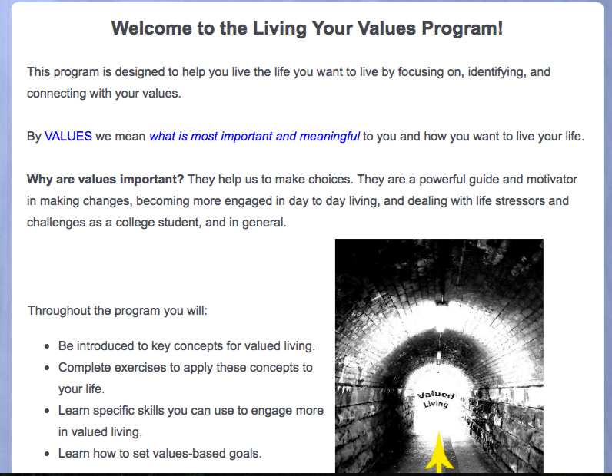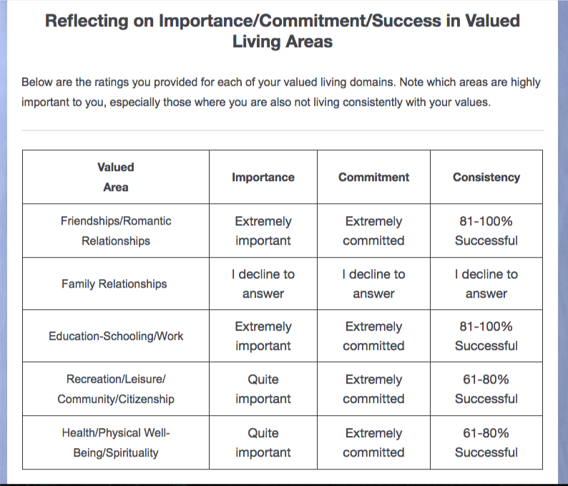
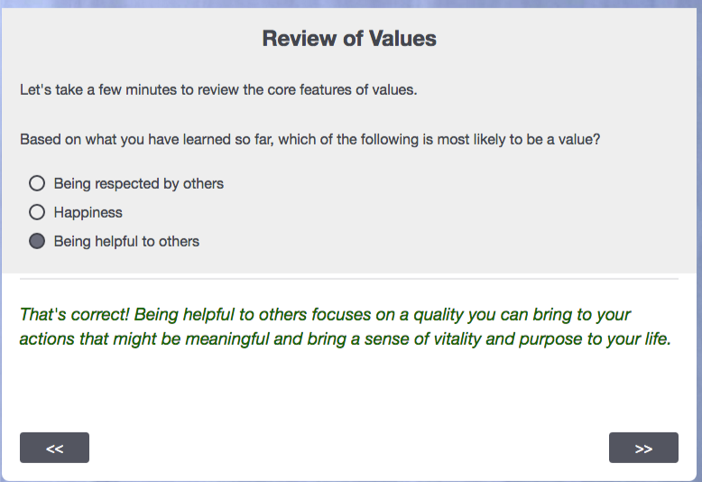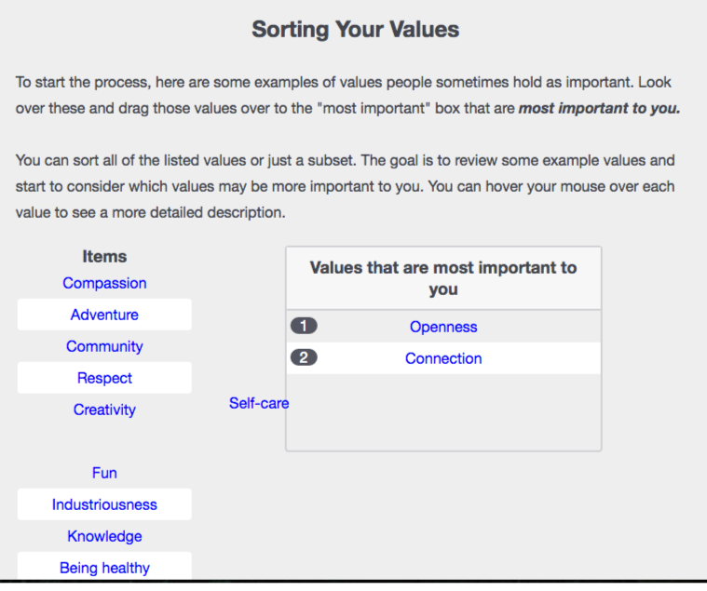
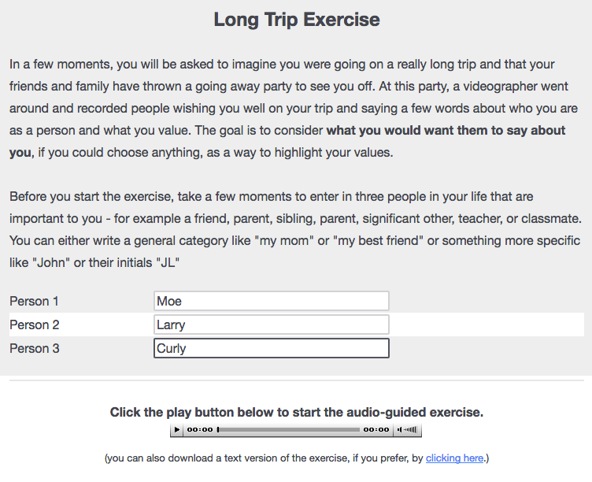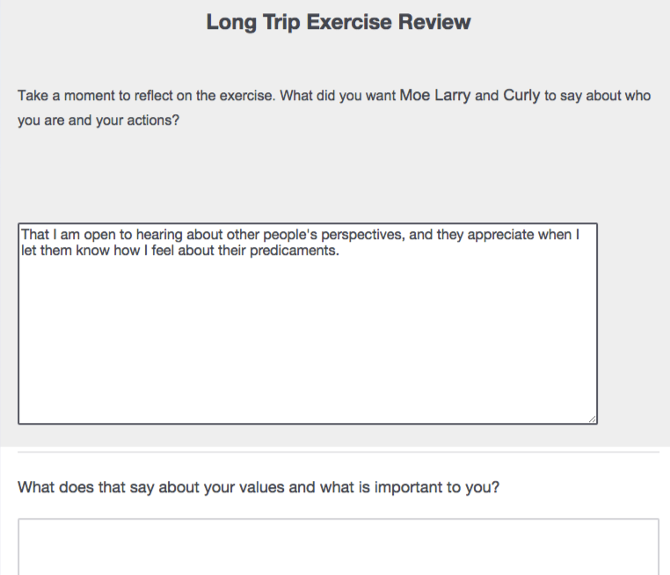

Figure 2. Sample of screen-captured images from the LYV program

