Moderators and preliminary processes of change in a randomized controlled trial of a fully automated, website delivering AEBT for adults with trichotillomania

Leila K. Capel
Julie M. Petersen
Michael E. Levin
Michael P. Twohig
Utah State University

Corresponding Author:
Leila K. Capel
Department of Psychology, Utah State University
2810 Old Main Hill, Logan, UT 84344
Phone: (435)994- 8619, Email: leila.capel@usu.edu

Abstract
Introduction. Access to treatment for trichotillomania has barriers and many people never receive evidence-based treatment. Understanding what treatments and modalities work, and how people get better through those treatments and modalities, is needed. Methods. We include analyses of moderators of treatment outcomes and preliminary processes of change from a randomized controlled trial assessing the efficacy of a fully automated website delivering acceptance-enhanced behavior therapy (AEBT) for adults (N=81) with trichotillomania. All participants received an eight-module website of AEBT, and assessments were completed at baseline, mid-, post-treatment, and a one-month follow-up. Using multilevel modeling, the moderation effects of baseline trichotillomania specific psychological flexibility, age, baseline and time -varying anxiety, and baseline and time varying depression were explored. Preliminary process of change using psychological flexibility was explored. Results. Baseline trichotillomania-specific psychological flexibility is correlated with changes in symptom severity over time but not by condition. Lower trichotillomania specific psychological flexibility at baseline was associated with better outcomes. Age also moderated treatment outcomes, specifically, participants between 18-30 had better treatment outcomes than participants over 30 years old. Baseline anxiety correlated with symptom severity but did not moderate intervention effects. Changes in anxiety were correlated with symptom severity over time. Baseline depression was not a significant moderator. Preliminary process of change analyses suggests that changes in psychological flexibility is correlated with changes in trichotillomania symptom severity across time. This relationship did not change in strength over time and was not moderated by condition. Conclusion. This study highlights how baseline trichotillomania specific psychological flexibility and anxiety impact changes in symptom severity and the function in a website delivered AEBT for adults with trichotillomania. Additionally, it provides preliminary support of the role of trichotillomania-specific psychological flexibility as a process of change in treatment of trichotillomania. Implications are discussed.
Keywords: trichotillomania, moderation, processes of change, acceptance-enhanced behavior therapy, self-help, website
Moderators and Processes of Change in a Randomized Controlled Trial of a Fully Automated Website Delivering AEBT for Adults with Trichotillomania
Trichotillomania is a debilitating disorder involving repetitive hair pulling and visible hair loss (American Psychiatric Association [APA], 2013). Individuals who struggle with hair pulling report significant distress and functional impairments, including difficulties with comorbid mental health concerns and social/work engagement (Grant et al., 2017a; Tung et al., 2015). A supported treatment for trichotillomania is presently habit reversal training (HRT; see Morris et al., 2013) which demonstrates good outcomes in adults and adolescents, but gains are questionable (Franklin et al., 2011).
Thus, combined treatment options for hair pulling have been a recent focus of empirical investigation. Acceptance-enhanced behavior therapy (AEBT; Woods & Twohig, 2023; Twohig et al., 2021) was specifically created to combine strategies from HRT with those from acceptance and commitment therapy (ACT) to target pulling and internal experiences associated with pulling (e.g., urges, shame). AEBT has been tested across formats including in person (e.g., Woods et al., 2022; Lee et al., 2018b), telehealth, (e.g., Lee et al., 2018a) and in group settings (e.g., Haaland et al., 2017). Most recently, a study by [MASKED] (2023) sought to test the efficacy and feasibility of an AEBT treatment website for adults with trichotillomania. Results of this randomized waitlist-controlled trial showed a significant decrease in symptom severity and psychological inflexibility from pre- to post- treatment and follow-up (53% of participants met treatment responder status; MASKED). Additionally, there was a statistically significant change in symptoms of distress (depression, anxiety, stress) across time and condition. Participants in the treatment condition also reported statistically significant increase in well-being.
This study utilizes data from the aforementioned trial of the AEBT treatment website in order to gain a better understanding of how AEBT works and for whom it might work best for. This approach is consistent with the growing research on process-based therapy, which stipulates that research and treatment approaches should focus on identifying the most relevant processes and characteristics for individuals as a part of the therapeutic process via procedures like moderation and/or mediation analyses (Hofmann & Hayes, 2019). There is little research on moderators of AEBT outcomes or processes of change for adults with trichotillomania. We will examine the following moderators of an AEBT website outcomes: trichotillomania-specific psychological inflexibility, age, anxiety, and depression and preliminary evaluations of trichotillomania-specific psychological flexibility as a process of change.
Psychological flexibility is considered the primary process of change of ACT and a central treatment target for AEBT. Psychological flexibility is the ability to remain connected to the moment, acting on what is important, rather than what is dictated by internal experiences (e.g., pulling because the urge is present: Ong & Eustis, 2021). In a recent trial comparing AEBT and supportive therapy for adults with trichotillomania, individuals with lower baseline levels of psychological flexibility responded better to AEBT, reporting greater improvements in symptoms and quality of life (Ong et al., 2023). Lower baseline psychological flexibility also acted as a predictor for a higher likelihood of recovery in AEBT. However, in a trial of telehealth AEBT for adolescents with trichotillomania, baseline psychological flexibility did not act as a moderator of treatment outcome (Petersen et al., 2022). Within that same study, there was evidence suggesting that psychological flexibility may impact symptom severity on a weekly basis, suggesting that psychological flexibility is of relevance and worthy of further investigation. In general, it is likely that those who are low on psychological flexibility would perform better in ACT-based treatments, as flexibility would theoretically grow in response to intervention. Overall, though, there is the need for more empirical support for this conjecture within AEBT.
Age is also under researched as a moderator of AEBT outcomes in adults; to our knowledge, it has not been assessed as a moderator before for the treatment of adult trichotillomania. Because trichotillomania often begins in adolescence (APA, 2013), age of the treatment-seeking individual may be especially important. Those who seek treatment earlier (i.e., younger individuals) may respond better to treatment because they have fewer years of learned behavior. Age may also be an especially important moderator for a self-guided website. For example, if the website proved stronger for younger people, dissemination efforts of the website can be focused on younger age ranges while further research can focus on effectively adapting the website for older adults. One vignette study of college students found that the age of a client presented in a vignette about trichotillomania treatment did not influence perceived acceptability of treatment (Elliot & Fuqua, 2002). Overall, the current research on age and treatment response in trichotillomania focuses on youth with mixed outcomes (e.g., Franklin et al., 2010). As one example, Petersen and colleagues (2022) also found that age was not a significant moderator of treatment outcome at post-treatment or longitudinal timepoints in a sample of adolescents who received telehealth AEBT. Because most research on age and treatment response focuses on youth and/or vignette/experimental formats, it is important to consider how age may be influencing outcomes for adults with trichotillomania, especially those receiving treatment in a self-guided format.
Lastly, examining anxiety and depression as potential moderators of AEBT outcomes is also worthwhile. Theoretically, those with higher baseline anxiety and/or depression may struggle to engage with therapy for trichotillomania, especially in a self-guided format. Depressive symptoms like anhedonia and/or low motivation may make it challenging for an individual to engage consistently with each session, as well as implement AEBT skills. Similarly, symptoms of anxiety such as difficulty concentrating or constant worry may also interfere with website engagement and use. Previous research has established that adults with anxiety and trichotillomania are more likely to report worse hair pulling symptoms and have co-occurring depression than those without co-occurring anxiety (Grant et al., 2017b; Alexander et al, 2017). In a large sample of adults with TTM (N = 530), 10.3% had co-occurring major depressive disorder (MDD) and 18.3% had co-occurring anxiety disorders (Grant et al., 2017b). Those with MDD reported worse symptoms than those with only anxiety, and combo of anxiety and depression had the worst symptoms. These results collectively suggest that anxiety and depression at baseline are serious and prevalent issues in adults with trichotillomania and may subsequently impact trichotillomania severity and treatment response. Lastly, research on the impact of comorbidity on AEBT is broadly nascent. In one study of adolescents who received telehealth AEBT, greater comorbid conditions predicted better treatment response in adolescents (Petersen et al., 2022). However, there are not comparable results available for the treatment of trichotillomania in adults. Because previous research suggests that comorbid conditions or symptoms may impact trichotillomania severity, this is an important area of work for not only understanding how AEBT might work, but also for who the online self-guided intervention might be best for.
In this study, we will analyze data from a randomized waitlist-controlled trial examining the efficacy and feasibility of AEBT as a treatment for adults with trichotillomania (MASKED). We will examine moderators of outcomes including age, psychological flexibility, anxiety, and depression at baseline and over time. We predict that age will moderate treatment outcomes such that younger participants will have greater decreases in symptom severity than older participants. We predict that psychological flexibility at baseline will moderate treatment outcomes such that participants with lower psychological flexibility at baseline will have greater decreases in symptom severity. We predict that anxiety and depression will moderate treatment outcomes such that participants with higher levels of anxiety and depression will have a smaller treatment response than participants with lower levels of anxiety and depression. We will also preliminarily examine trichotillomania specific psychological flexibility as a process of change. We predict that psychological flexibility will act as a process of change in treatment such that greater changes in psychological flexibility will predict greater changes in symptom severity. The main purpose is to add to the growing body of research on how AEBT works and for whom, furthering process-based therapy in trichotillomania.
Methods
Participants
The sample in the present study was largely homogenous despite recruitment taking place across the United States. Participants (N=81) were a mean age of 30 years old and primarily identified as women, White, and non-Hispanic. Full participant demographics are available in the publication concerning the efficacy of the intervention. Please see [MASKED] for full participant demographics. Additionally, as part of the treatment program, participants completed the Milwaukee Inventory for Subtypes of Trichotillomania- Adult Version (MIST-A) to help them gain a better understanding of their pulling but not all participants completed the measure or partially completed it. This is likely attributable to administration in the context of the treatment program rather than as a part of the pre-assessment battery. Overall, participants in this study reported automatic pulling scores between 20-75 and focused pulling scores between 33-70. As is seen in the larger population, average scores on the MIST-A are 51 for automatic pulling and 45 for focused pulling (Flessner et al., 2008), meaning our participants are consistent with other trichotillomania samples. Participants were recruited across the United States utilizing ads and posts on social media platforms (e.g., Facebook, Reddit) for trichotillomania. All participants included in the data analyses met the following criteria: (a) met DSM-V criteria for trichotillomania, (b) were searching for trichotillomania-based treatment, (c) were at least 18 years old, (d) were living in the United States, and (e) were fluent English speakers. Participants were excluded if they were modifying or starting a psychotropic medication, were living outside the United States, were under the age of 18, were receiving alternative psychotherapy, and/or did not meet diagnostic criteria for trichotillomania.
Procedures
This study was approved by the [MASKED] Institutional Review Board. Participants were recruited through online support groups and trichotillomania forums on Facebook and reddit. Participants were provided information about the duration of the study (12-weeks), the nature of the treatment (self-help AEBT website), and the likelihood of being randomized into the treatment or waitlist condition. Participants interested in participating were prompted to contact the research team through an online screener survey assessing initial eligibility criteria. Participants who met initial eligibility criteria (e.g., over 18 years old, living in the United States) were provided informed consent to review and sign after which they were scheduled for a zoom based intake interview. During the intake interview, participants completed a semi-structured diagnostic assessment (the Diagnostic Interview for Anxiety, Mood, and Obsessive-Compulsive and Related Neuropsychiatric Disorders [DIAMOND]) to ensure they met diagnostic criteria for trichotillomania. As the final part of the intake interview, participants complete the pre-assessment (considered “week 0” or “time 0” for the purposes of the current analyses) which contained various measures related to hair pulling symptom severity, well-being, overall distress, depression, anxiety, stress, and psychological flexibility (see Measures section). All participants who completed the intake interview met eligibility criteria and were enrolled in the study (N=81). Participants were informed that they could withdraw from the study at any time. Please see [MASKED] for participant consort diagram.
Following the intake, participants were randomized into the treatment or waitlist condition (Participants in the treatment condition completed an 8-week online web-based treatment of AEBT with a one-month follow-up assessment (12-weeks) and participants in the waitlist condition were put on a 12-week waitlist. All study measures (including the full assessment battery) were administered at pre- (week 0; N= 81), mid- (week 4; N=77), post-treatment (week 8; N=76), and one month follow-up (week 12; N= 73). While completing the web-based treatment, participants completed the MIST-A to better understand and characterize their pulling patterns (e.g., levels of automatic and focused pulling). This was not administered as part of the assessment battery and thus data from this measure is not representative of all participants. Of the 81 participants enrolled at intake, 80 participants remained enrolled for the duration of the study. One participant chose to withdraw from the study one week after the intake based on the recommendation of a medical provider. Participants choosing to withdraw were given the choice of having their data removed from the study. Based on participants preference, all 81 participants data were used in analyses.
Measures
Demographics
During the pre-assessment, participants were asked demographic questions including sex assigned at birth, current gender identity, age, and racial and ethnic identity.
Milwaukee Inventory for Subtypes of Trichotillomania- Adult Version (MIST-A; Flessner et al., 2008)
The MIST-A is a 15-item, self-report measure designed to characterize styles of pulling into “automatic” or outside of the awareness of the individual, and “focused” or within the awareness of the individual. An example of an automatic pulling question is “I don’t notice that I have pulled my hair until after it’s happened.” An example of a focused pulling question is “I pull my hair to control how I feel.” Each item is rated on a 9 point scale ranging from 1 (not true of any of my pulling) to 9 (true of all my pulling). The MIST-A has good internal consistency and validity (Flessner et al., 2008).
Massachusetts General Hospital Hair Pulling Scale (MGH-HPS; Keuthen et al., 1995)
The MGH-HPS is a 7-item, self-report measure of trichotillomania symptoms. Participants were asked questions regarding their urge to pull, actual engagement in pulling, and distress associated with pulling. Questions are rated on a 5-point Likert scale, with higher scores indicating greater trichotillomania severity (scoring ranges from 0 to 28). Previous research has established that a seven-point change is sufficient to indicate treatment response (Houghton et al., 2015). Previous research has supported good reliability and validity of the MGH-HPS (e.g., Keuthen et al., 1995), which was consistent with reliability in the present sample (Cronbach’s alpha = 0.79).
Acceptance and Action Questionnaire for Trichotillomania (AAQ- TTM; Houghton et al., 2014)
The AAQ-TTM is a nine-item self-report questionnaire that measures psychological inflexibility specific to trichotillomania-related symptoms. Participants rate each item on a 7-point Likert scale (1 = Never true, 7 = Always true). Scores for the AAQ-TTM range from 7 to 63, with higher scores indicating greater psychological inflexibility (i.e., less psychological flexibility). Previous research has established good validity and reliability with the AAQ-TTM (e.g., Houghton et al., 2015). However, in the present study, the reliability at pre-treatment was within the unacceptable range (Cronbach’s alpha = 0.66). Closer examination of other timepoints indicated that the internal consistency was acceptable for the rest of the study (Cronbach’s alpha = 0.79).
Depression, Anxiety, and Stress Scale – 21 (DASS-21, Lovibond & Lovibond, 1995)
The DASS-21 is a self-report questionnaire measuring depression, anxiety, and stress. It is a shortened version of the full DASS, which included 42 items. Example items include “I felt that I had nothing to look forward to,” “I felt I was close to panic,” and “I tended to over-react to situations” for depression, anxiety, and stress, respectively. Each item is rated on a 4-point Likert scale (0 = Did not apply to me at all, 3 = Applied to me very much or most of the time) for the past week. Past research has confirmed good validity and reliability of the DASS-21 (e.g., Osman et al., 2012); the reliability in the current study was good (Cronbach’s alpha = 0.87).
Analysis
Between group differences were assessed at baseline between the ACT and waitlist conditions. No significant differences were observed between groups at baseline on all measures including trichotillomania symptom severity, psychological flexibility, anxiety, or depression. Please see [MASKED] for more information on the preliminary analyses.
Moderation. Multilevel models were used to determine moderators of change over time on the main outcome (MGH-HPS) between condition. Multilevel models were used because of the longitudinal and hierarchical structure of the data (e.g., timepoints by week: Level 1; individual participants: Level 2); and incomplete cases at various time points (Hox et al., 2017). The analyses were two level multilevel longitudinal models with random intercepts and slopes. Moderators included baseline trichotillomania specific psychological flexibility (AAQ-TTM), baseline and time-varying depression (DASS-21 Depression), baseline and time-varying anxiety (DASS-21 Anxiety), and age at baseline. Each moderator was tested independently to assess the moderators individual effect on treatment outcomes (e.g., psychological flexibility moderating symptom severity; anxiety moderating symptom severity). The analyses were conducted in this manner based on theory suggesting that each moderator would individually impact treatment outcomes.
Process of Change. Preliminary process of change analyses were completed using multilevel models to assess the effect of time varying trichotillomania-specific psychological flexibility on changes in symptom severity over the course of treatment. Time varying analyses in multilevel modeling assess if change in the predictor variable is correlated with the outcome variable (e.g., as psychological flexibility increases or decreases, symptom severity increases or decreases). It also assesses the strength of the relationship over time (e.g., does the predictor variable have greater or lesser impact on the outcome at different timepoints). Multilevel models were used in the process of change analyses because of the longitudinal and hierarchical structure of the data and to better account for incomplete data (Hox et al., 2017).
All analyses were run in R (R Core Team, 2022) using the lme4 package (Bates, Macchler, Bolker, & Walker, 2015). Nested models were conducted in a series for each moderator and process of change variable to identify the best fitting model. To assess which model was the best fitting model, using a likelihood ratio test (p<.05), each model was compared to the previously identified best fitting model (e.g. the model with no interactions was compared to the model with interactions).

Results
Moderation.
Trichotillomania-specific psychological flexibility. The best-fitting model for baseline trichotillomania specific psychological flexibility as a moderator of change in symptom severity indicated that trichotillomania psychological flexibility predicts symptom severity over time (significant baseline AAQ-TTM by time interaction in predicting symptom severity) but did not interact with treatment condition. Lower baseline psychological flexibility significantly predicted changes in symptom severity over time. See Table 1 for the model building. Please see Figure 1 for a plot of the relationship between baseline psychological flexibility and symptom severity.
Age. The best fitting model for age at baseline as a moderator of change in symptom severity indicated that age at baseline significantly predicted change in symptom severity over time and by condition. There was an interaction between age, condition, time in this model. Younger participants, between the age of 18-30 years old in the treatment condition had significantly greater reductions in symptom severity over time compared to participants over 30 (e.g., 31-40; 41-50; 50 and older). This should be interpreted with caution given the limited variability in age of participants and limited sample in each age group. Please see Table 2 for model building and Figure 2 for a plot of the relationship between baseline age and symptom severity.
Depression. The best-fitting model for baseline depression as a moderator of change in symptom severity indicated that baseline depression did not significantly predict change in symptom severity over time or by condition. The best-fitting model for time varying depression as a moderator of change in symptom severity indicated that time varying depression did not significantly predict change in symptom severity over time or by condition. This is expected given the targeted nature of the treatment and is consistent with previous research indicating that change in depression is not necessary to effectively treat trichotillomania.
Anxiety. The best fitting model for baseline anxiety as a moderator of change in symptom severity did not suggest that baseline anxiety is a moderator of change in symptom severity. Baseline anxiety had a main effect in predicting symptom severity, but baseline anxiety did not significantly interact with time or condition. See Table 3 for model building. The best-fitting model for time varying anxiety suggests that changes in anxiety is related with changes in trichotillomania symptoms. This relationship did not change over time or by condition (as indicated by non-significant interactions between time varying anxiety and time and condition variables). See Table 4 for model building.
Process of change.
Trichotillomania-specific psychological flexibility. The best-fitting model for time varying trichotillomania specific psychological flexibility as a preliminary process of change suggested that changes in psychological flexibility are related with changes in trichotillomania symptom severity over time. This relationship did not vary across time or by condition (as indicated by non-significant interactions between time varying psychological flexibility and time and condition variables). See Table 5 for model building. See Figure 3 for a plot of the relationship between time varying trichotillomania psychological flexibility and symptom severity across time.
Discussion
We examined moderators of treatment outcomes including trichotillomania-specific psychological flexibility, age, depression, and anxiety, and processes of change including trichotillomania-specific psychological flexibility for adults completing a fully autonomous treatment website for trichotillomania. Very little research explores moderators and processes of change in treatment for adults with trichotillomania. The growing body of literature on process-based therapy supports the importance of understanding the therapeutic processes (Hoffman & Hayes, 2019) to best understand how and for whom specific treatments may be best suited.
Moderators.
Trichotillomania-specific psychological flexibility. Baseline trichotillomania-specific psychological flexibility is predictive of changes in symptom severity over time but did not moderate the effects of treatment relative to the waitlist condition. Individuals with lower trichotillomania-specific psychological flexibility at baseline had greater decreases in symptom severity across conditions. Our findings were consistent with Ong and colleagues (2023) findings that lower baseline psychological flexibility predicted greater decreases in symptom severity. However, these findings were not consistent with those of the study by Petersen and colleagues (2022) which did not find baseline psychological flexibility as a predictor of change in symptom severity in adolescents. This discrepancy may be explained by differences in the way that psychological flexibility functions in adolescent trichotillomania as compared to adults. Perhaps psychological flexibility is less important in symptom maintenance and severity is adolescents but increases in adulthood as the conceptualization of the self and identity becomes more developed. Overall, these finding suggest that psychological flexibility has a main effect in predicting symptom severity over time, but response to AEBT relative to a waitlist condition does not change based on level of baseline psychological flexibility.
Age. Age, to our knowledge, has not be explored as a moderator of change in treatment for adults with trichotillomania. Previous research on age as a moderator of change in trichotillomania has focused on adolescent treatments. In a study by Petersen and colleagues (2022), age was not found to moderate treatment outcomes. In the present study, age significantly moderated treatment outcomes and specifically, participants between 18-30 years had better treatment outcomes than older participants (see results section for age group delineations). As previously discussed, because trichotillomania often begins in early adolescence, individuals seeking treatment earlier may respond better to treatment because they have had less time to strengthen their trichotillomania. Another explanation for the differences in this finding from previous research could be related to the delivery method. Petersen and colleagues (2022) examined moderators of telehealth delivered format and the present study examined moderators of a web-based format. These findings may suggest a need for adaptation to the website itself for olde adults. Interestingly, consistent with previous research, acceptability of the study was overwhelmingly positive despite differences in treatment response based on age (e.g., Elliot & Fuqua, 2002). This finding has implications on dissemination efforts given the online, self-guided nature of this intervention and may support examination of adaptations or tailoring of the website for different age groups.
Depression. Previous researchers have suggested that individuals with co-occurring depressive symptoms are more likely to report worse pulling symptoms than adults without co-occurring depressive or anxiety symptoms (Grant et al., 2017b). Depression at baseline and over time was not a significant predictor or moderator of treatment outcomes on symptom severity in the present study. This finding suggests that treating depressive symptoms is not necessarily needed to effectively treat trichotillomania. It is possible that if depression is not playing a causal role in elevating trichotillomania symptoms, the effect on trichotillomania treatment would not be significant (Grant et al., 2017b). Greater research on moderators of trichotillomania treatment is necessary for a greater understanding of the role of co-occurring depression on treatment for adults.
Anxiety. Previous researchers suggested that anxiety had a significant impact on trichotillomania severity and likely would impact treatment outcomes (Grant et al., 2017b; Houghton et al., 2016). Baseline anxiety is related to symptom severity such that individuals with higher levels of anxiety at baseline also had higher levels of trichotillomania symptom severity but this relationship did not predict how symptom severity changed over time and did not moderate intervention effects relative to the waitlist. Baseline anxiety does not alter whether an individual would benefit from this intervention (e.g., experience decreases in trichotillomania symptom severity).
Individuals with greater changes in anxiety had greater changes in symptoms severity over time. The relationship did not change in strength (e.g., become stronger or weaker) as a function of time and the relationship was not moderated by condition. This is consistent with findings from previous studies that suggest the correlation between anxiety and symptom severity (e.g., Grant et al., 2017a; Grant et al., 2020). Petersen and colleagues (2022) found that adolescent with trichotillomania and with greater comorbid conditions had better treatment response. Our findings provide preliminary evidence that anxiety is correlated with trichotillomania symptom severity but may not prevent someone from benefiting from the intervention. More research is needed to better understand the role of anxiety on changes in symptom severity and treatment outcomes.
Processes of Change.
Trichotillomania-specific psychological flexibility. Changes in trichotillomania psychological flexibility were related with changes in trichotillomania symptom severity across time. This relationship remains the same over time (e.g., it does not become stronger or weaker over time) and the relationship was not moderated by condition. These findings provide preliminary support of psychological flexibility as a process of change in AEBT treatment delivered through a fully automated website. Our findings on the role of changes in psychological flexibility support the study by Petersen and colleagues (2022) suggesting that increases in psychological flexibility predicted decreases in symptom severity over time. It appears that trichotillomania psychological flexibility plays role in changes in trichotillomania symptom severity. However, more research is needed on trichotillomania psychological flexibility as a process of change to support and elaborate on these findings.
Clinical Implications. The findings of the current study have important clinical implications in service of better understanding how AEBT works and for whom it is best suited. The findings on trichotillomania-specific psychological flexibility, both at baseline and over time, suggest that psychological flexibility is predictive of change in symptom severity. While we cannot infer a causal relationship, the findings of this study suggest that when psychological flexibility increases, symptom severity in trichotillomania decreases which is consistent with the findings from Ong and colleagues (2022). This coupled with many previous trials provides evidence in support of psychological flexibility as a viable treatment target in AEBT. Additionally, given that individuals between 18-30 years old responded better to the treatment than older participants, it is likely beneficial to focus dissemination efforts on individuals in these younger age ranges. This could involve more targeted marketing toward these age groups through modalities like Facebook Ads in addition to dissemination and marketing more broadly. The findings on depression and anxiety also have clinical implications. Previous research suggests that individuals with co-occurring anxiety or depression and trichotillomania may have more difficulty seeing improvements in treatment. Based on the findings of this study, it is possible that individuals with co-occurring conditions may still benefit from this intervention with respect to trichotillomania symptom severity. Similar findings have occurred in other ACT trials (e.g., Arch et al., 2012). This was not the expected finding but may be explained by greater openness or honesty in engagement with the website which may not occur in-person or face-to-face therapy. More research is necessary to explore this conjecture.
Limitations. The findings of this study add to the current literature and are theoretically useful regarding factors that moderate change in AEBT and trichotillomania symptom severity. Additionally, it provides preliminary support for trichotillomania specific psychological flexibility as a process of change in trichotillomania. However, there are limitations that should be noted. First, the sample is primarily female even though research currently suggests that prevalence rates are equal across sex. This is however to be expected because more females seek services than males (Grant et al., 2020). Future research should seek a more heterogeneous sample. A more heterogenous sample would provide more information on prevalence rates and other factors that moderate treatment outcomes like race, ethnicity, and gender. This would also allow for development of necessary treatment adaptations to decrease health disparities across these domains. Additionally, the sample was primarily clustered in age between 18-50 years old which may impact the results found around age as a moderator of treatment outcomes. Given the findings that younger adults responded better to the treatment, future research should focus on effectively adapting the website to older adults or individuals who have been experiencing trichotillomania symptoms for longer periods. Additionally, comorbidities were not assessed, and this may be an important moderator of treatment outcomes and should be assessed in future research. Another limitation of the study is that participants were not excluded based on previous therapy for trichotillomania with ACT or HRT which may have impacted the efficacy and findings related to moderators of treatment outcomes. Finally, given the heterogeneity of trichotillomania and the potential impact pulling style may have on treatment outcomes it would be beneficial to assess this as a moderator of treatment. Given how the MIST-A was administered, the available data was not sufficient to use in moderation analyses. Future studies should seek to evaluate the role of pulling styles on treatment outcomes.
Conclusion. We found preliminary support of AEBT as a useful intervention for adults with trichotillomania by targeting psychological flexibility given the correlation between changes in psychological flexibility and changes in symptom severity. Additionally, age was a significant moderator of change in symptom severity over time. Finally, anxiety was a significant predictor of change in symptom severity over the course of treatment and indicated that individuals with co-occurring anxiety disorders may benefit from this treatment. These findings are theoretically consistent with conjectures from previous research, however, additional studies examining moderators and processes of change in treatment for adults with trichotillomania is necessary to better understand how the treatment works and who will benefit most from it.

References
Alexander, J. R., Houghton, D. C., Twohig, M. P., Franklin, M. E., Saunders, S. M., Neal-Barnett, A. M., ... & Woods, D. W. (2017). Clarifying the relationship between Trichotillomania and anxiety. Journal of obsessive-compulsive and related disorders, 13, 30-34.
Arch, J. J., Wolitzky-Taylor, K. B., Eifert, G. H., & Craske, M. G. (2012). Longitudinal treatment mediation of traditional cognitive behavioral therapy and acceptance and commitment therapy for anxiety disorders. Behaviour research and therapy, 50(7-8), 469-478.
American Psychiatric Association. (2013). Diagnostic and statistical manual of mental disorders: DSM-5™ (5th ed.). American Psychiatric Publishing, Inc. 10.1176/appi.books.9780890425596
Bates, D., Maechler, M., Bolker, B., & Walker, S. (2015). Fitting Linear Mixed-Effects Models Using lme4. Journal of Statistical Software, 67(1), 1-48. doi:10.18637/jss.v067.i01.
Capel, L.K., Petersen, J.M., Becker, M.R., Levin, M.L., Twohig, M.P. (2023). Examining the efficacy and feasibility of a web-based acceptance enhanced behavior therapy for trichotillomania: A randomized waitlist-controlled trial. Journal of Obsessive-Compulsive and Related Disorders.
Elliott, A. J., & Fuqua, R. W. (2002). Acceptability of treatments for trichotillomania: Effects of age and severity. Behavior Modification, 26(3), 378-399.
Flessner, C.A., Woods, D.W., Franklin, M.E., Cashin, S.E., Keuthen, N.J. (2008). The milwaukee inventory for subtypes of trichotillomania- adult version (MIST-A): Development of an instrument for the assessment of “focused” and “automatic” hair pulling. Journal of Psychopathology Behavior and Assessment, 30, 20-30. https://doi.org/10.1007/s10862-007-9073-x
Franklin, M. E., Edson, A. L., & Freeman, J. B. (2010). Behavior therapy for pediatric trichotillomania: exploring the effects of age on treatment outcome. Child and Adolescent Psychiatry and Mental Health, 4, 1-6.
Franklin, M. E., Zagrabbe, K., & Benavides, K. L. (2011). Trichotillomania and its treatment: A review and recommendations. Expert Review of Neurotherapeutics, 11(8), 1165-1174.
Grant, J. E., Redden, S. A., Leppink, E. W., & Chamberlain, S. R. (2017a). Trichotillomania and co-occurring anxiety. Comprehensive Psychiatry, 72, 1-5.
Grant, J. E., Redden, S. A., Medeiros, G. C., Odlaug, B. L., Curley, E. E., Tavares, H., & Keuthen, N. J. (2017b). Trichotillomania and its clinical relationship to depression and anxiety. International Journal of Psychiatry in Clinical Practice, 1-5. https://doi.org/10.1080/13651501.2017.1314509
Grant, J.E., Dougherty, D.D., & Chamberlin, S.R. (2020). Prevalence, gender correlates, and co-morbidity of trichotillomania. Psychiatry Research, 288. https://www.doi.org/10.1016/j.psychres.2020.112948
Haaland, A.T., Ekeland, S.O., Moen, E.M., Vogel, P.A., Haseth, S., Mellingen, K, Himle, J.A., Woods, D.W., Hummelen, B. (2017). ACT-enhanced behavior therapy in group format for trichotillomania: An effectiveness study. Journal of Obsessive-Compulsive and Related Disorders, 12, 109-116.
Hofmann, S. G., & Hayes, S. C. (2019). The future of intervention science: Process-based therapy. Clinical Psychological Science, 7(1), 37-50.
Houghton, D. C., Compton, S. N., Twohig, M. P., Saunders, S. M., Franklin, M. E., Neal-Barnett, A. M., Ely, L., Capriotti, M. R., & Woods, D. W. (2014). Measuring the role of psychological inflexibility in Trichotillomania. Psychiatry Research, 220(1-2), 356-361. https://doi.org/10.1016/j.psychres.2014.08.003
Houghton, D.C., Maas, J., Twohig, M.P., Saunders, S.M., Compton, S.N., Neal-Barnett, A.M., Franklin, M.E., Woods, D.W. (2016). Comorbidity and quality of life in adults with hair pulling disorder. Psychiatry Research 239(12-9), https://doi.org/10.1016/j.psychres.2016.02.063
Hox, J.J., Moerbeek, M., & Van de Schoot, R. (2017). Multilevel analysis: Techniques and applications, third edition. Taylor & Francis Group.
Keuthen, N. J., O’Sullivan, R. L., Ricciardi, J. N., Shera, D., Savage, C. R., Borgmann, A. S., Jenike, M. A., & Baer, L. (1995). The massachusetts general hospital (MGH) hairpulling scale: Development and factor analyses. Psychotherapy and Psychosomatics, 64(3), 141-145. https://doi.org/10.1159/000289003
Lee, E. B., Haeger, J. A., Levin, M. E., Ong, C. W., & Twohig, M. P. (2018a). Telepsychotherapy for trichotillomania: A randomized controlled trial of ACT-enhanced behavior therapy. Journal of Obsessive-Compulsive and Related Disorders, 18, 106-115. https://doi.org/10.1016;j/jocrd.2018.04.003
Lee, E. B., Homan, K. J., Morrison, K. L., Ong, C. W., Levin, M. E., & Twohig, M. P. (2018b). Acceptance and commitment therapy for trichotillomania: A randomized controlled trial of adults and adolescents. Behavior Modification. 44(1), 70-91. https://doi.org/10.1177/0145445518794366
Lovibond, S. H., & Lovibond, P. F. (1995). Manual for the Depression Anxiety Stress Scales. (2nd. Ed.).
Morris, S.H., Zickgraf, H.F., Dingfelder, H.E., Franklin, M. E. (2013). Habit reversal training in trichotillomania: Guide for the clinician. Expert Review of Neurotherapeutics, 13(9), 1069-1077.
Ong, C. W., & Eustis, E. H. (2021). Psychological flexibility. In M.P. Twohig, M.E. Levin, & J.M. Petersen (Eds.), The Oxford Handbook of Acceptance and Commitment Therapy. Oxford University Press.
Ong, C. W., Woods, D. W., Franklin, M. E., Saunders, S. M., Neal-Barnett, A. M., Compton, S. N., & Twohig, M. P. (2023). The role of psychological flexibility in acceptance-enhanced behavior therapy for trichotillomania: Moderation and mediation findings. Behaviour Research and Therapy, 164, 104302.
Osman, A., Wong, J. L., Bagge, C. L., Freedenthal, S., Gutierrez, P. M., & Lozano, G. (2012). The depression anxiety stress Scales—21 (DASS‐21): Further examination of dimensions, scale reliability, and correlates. Journal of Clinical Psychology, 68(12), 1322-1338.
Petersen, J.M., Capel, L.K., Levin, M.E., & Twohig, M.P. (2022). Moderators and processes of change in a pilot randomized controlled trial of acceptance-enhanced behavior therapy for trichotillomania in adolescents. Journal of Obsessive-Compulsive and Related Disorders.
Tung, E. S., Flessner, C. A., Grant, J. E., & Keuthen, N. J. (2015). Predictors of life disability in trichotillomania. Comprehensive Psychiatry, 56, 239-244.
Twohig, M. P., Petersen, J. M., Fruge, J., Ong, C. W., Barney, J. L., Krafft, J., Lee, E. B., & Levin, M. E. (2021). A Pilot randomized controlled trial of online delivered ACT-enhanced behavior therapy for trichotillomania in adolescents. Cognitive and Behavioral Practice. 28(4) 653-668. https://doi.org/10.1016/j.cbpra.2021.01.004
R Core Team (2022). R: A language and environment for statistical computing. R Foundation for Statistical Computing, Vienna, Austria. URL. https://www.R-project.org/
Woods, D.W. & Twohig, M.P. (2023). Trichotillomania: An ACT-enhanced Behavior Therapy Approach Therapist Guide. Second Edition. Oxford University Press.
Woods, D. W., Ely, L. J., Bauer, C. C., Twohig, M. P., Saunders, S. M., Compton, S. N., ... & Franklin, M. E. (2022). Acceptance-enhanced behavior therapy for trichotillomania in adults: A randomized clinical trial. Behaviour Research and Therapy, 158, 104187.

Table 1

Baseline psychological flexibility model building. 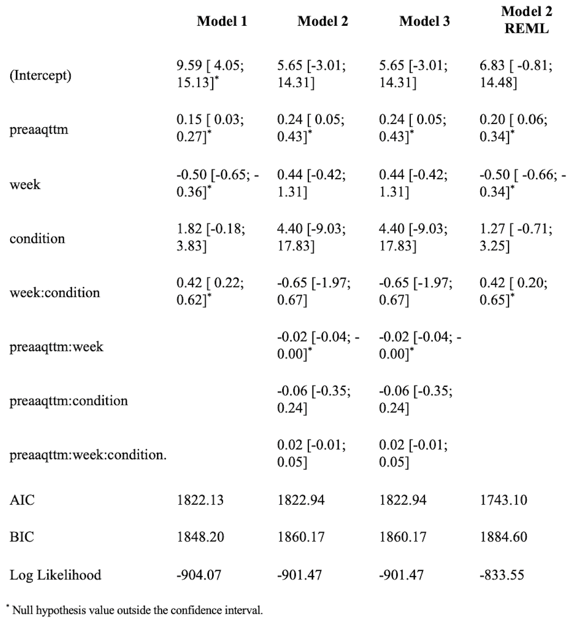
Note. preaaqttm = pre-assessment scores of Acceptance and Action Questionnaire- Trichotillomania; REML= Restricted maximum likelihood

Table 2
Age model building
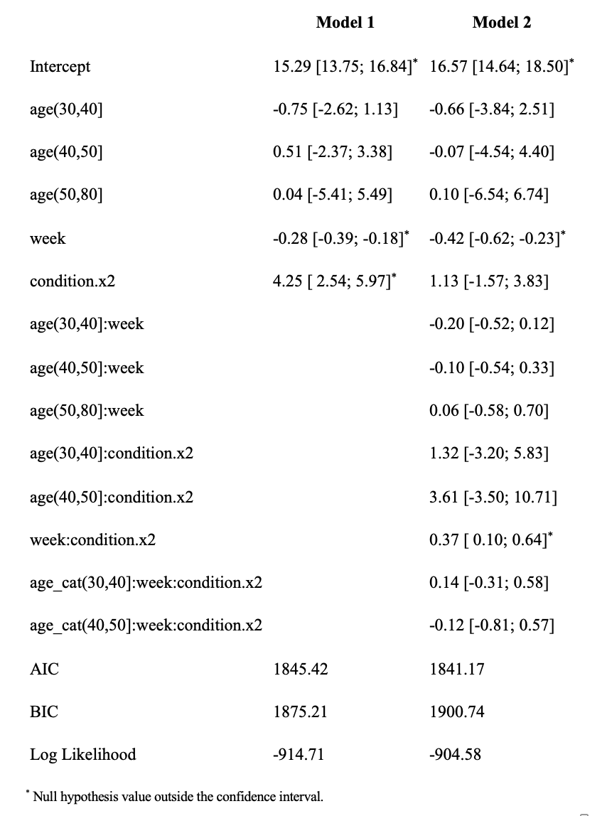

Table 3
Baseline anxiety model building
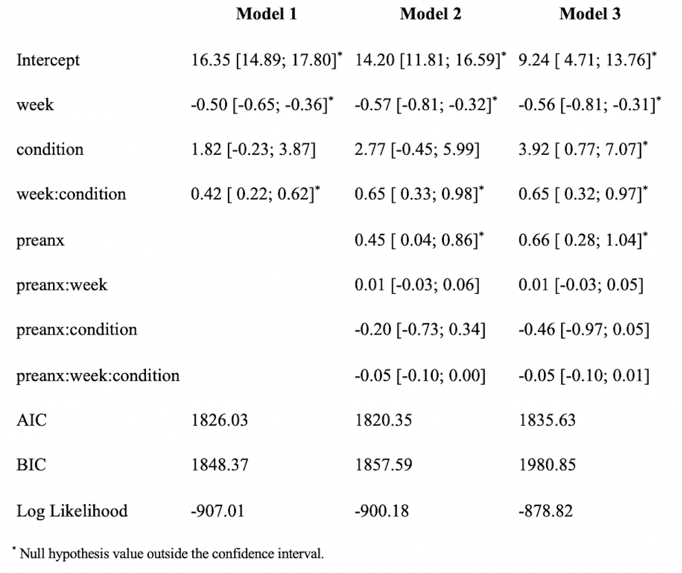

Note. Preanx= pre-assessment anxiety score from the DASS-21 Anxiety subscale

Table 4
Time varying anxiety model building

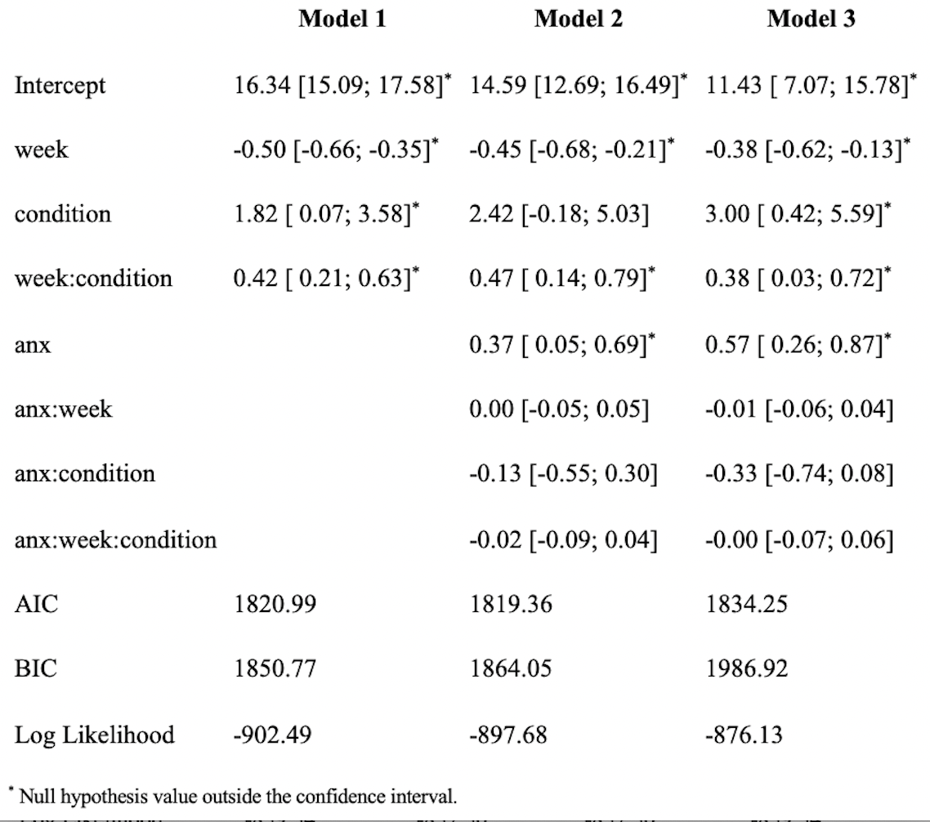
Note. Anx = anxiety scores from the DASS-21 Anxiety subscale

Table 5
Time varying psychological flexibility model building
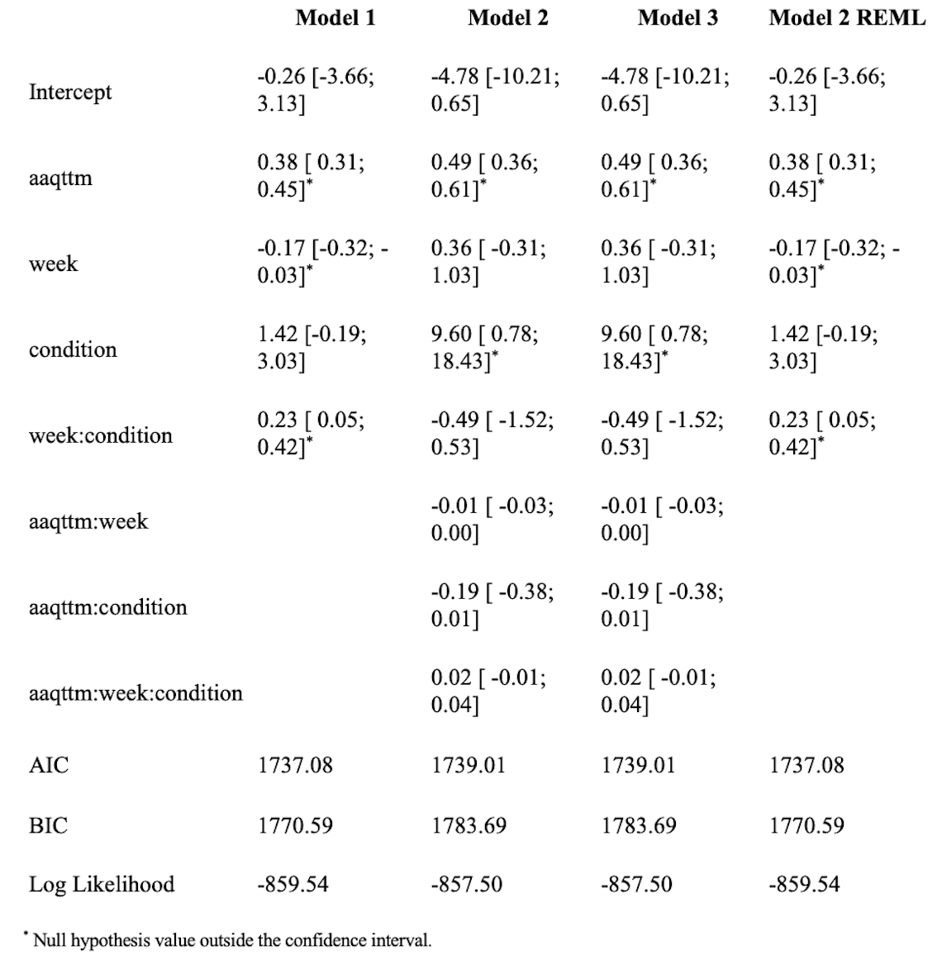
Note. aaqttm = Acceptance and Action Questionnaire- Trichotillomania

Figure 1
Baseline psychological flexibility predicting symptom severity over time and condition
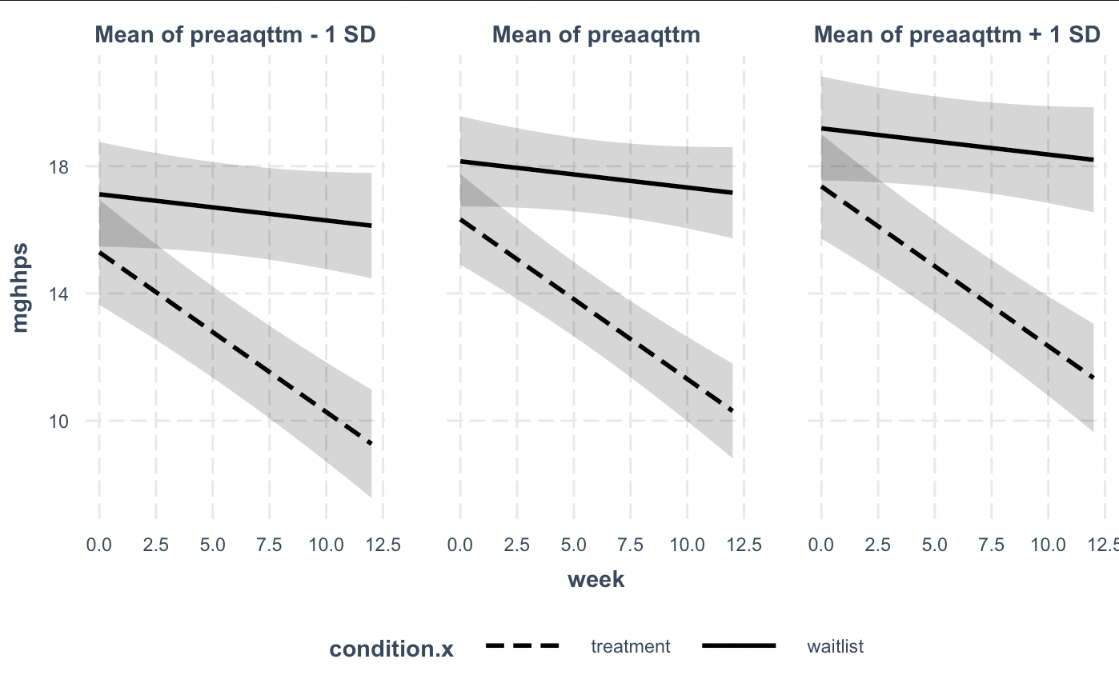
Note. Preaaqttm = pre-assessment scores on the Acceptance and Action Questionnaire for Trichotillomania

Figure 2
Baseline age on symptom severity over time.

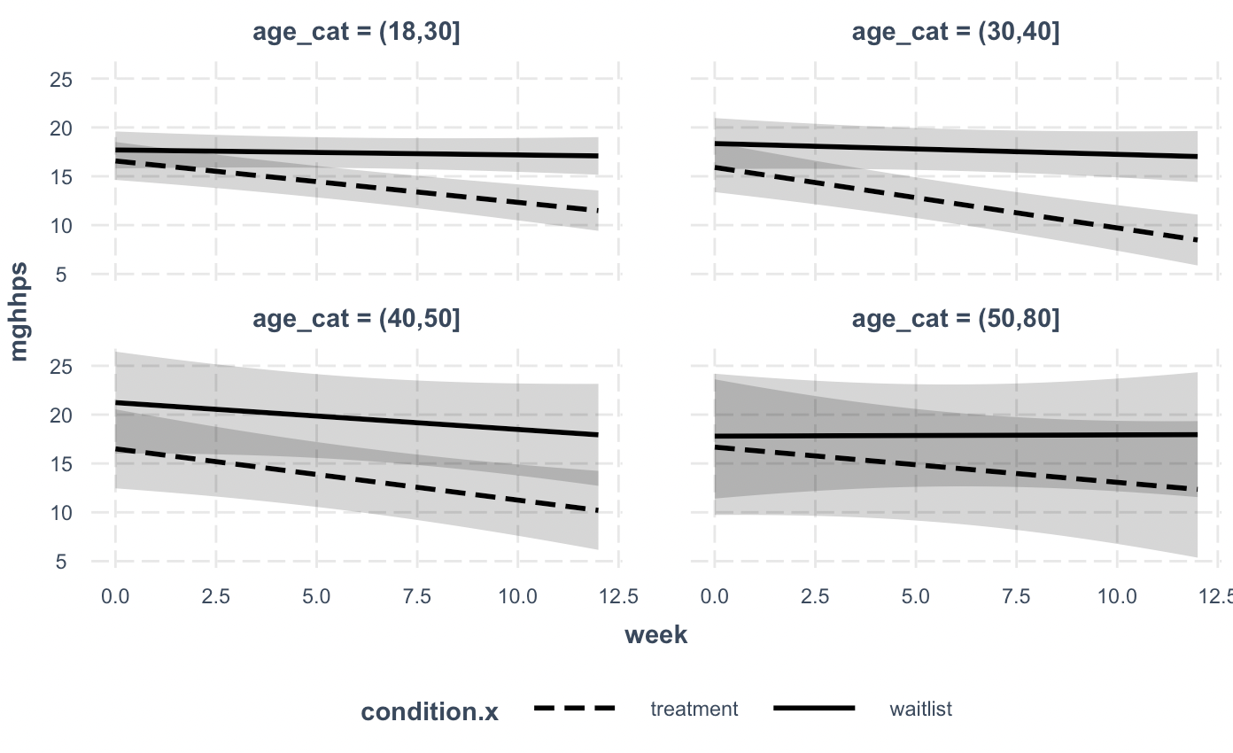

Figure 3
Change in psychological flexibility over time on symptom severity

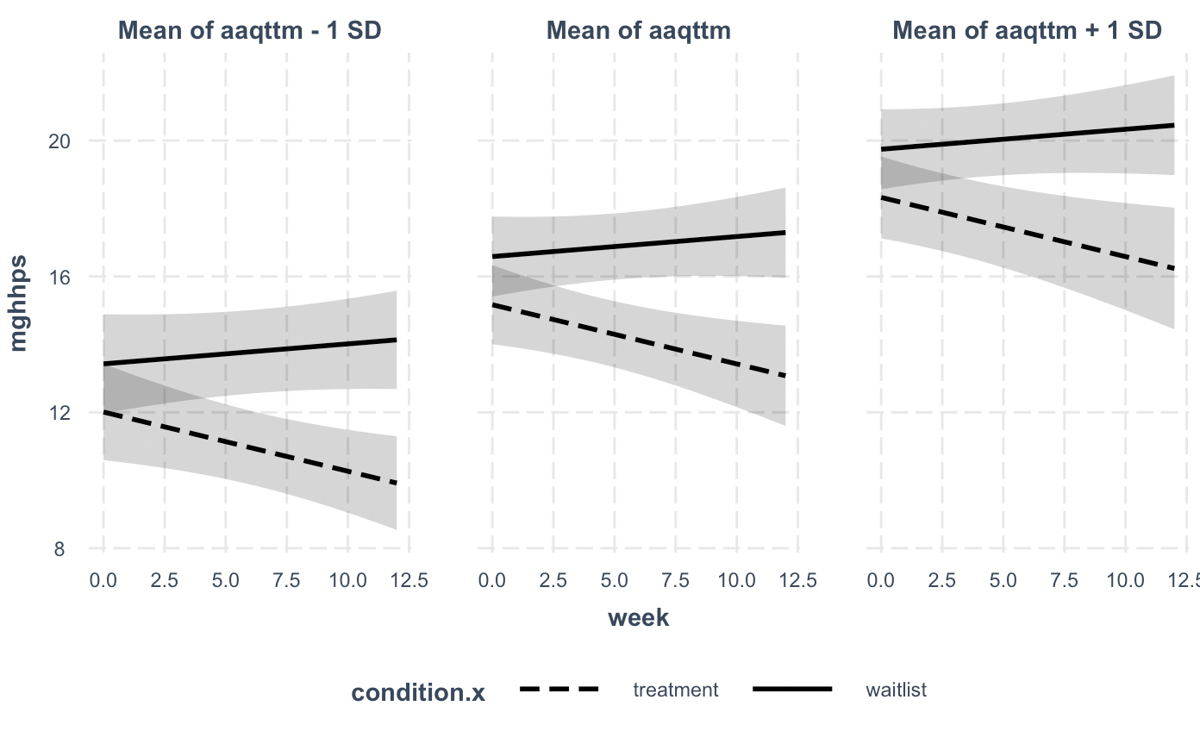

Note. AAQ-TTM = Acceptance and Action Questionnaire- Trichotillomania

