A pilot randomized controlled trial of culturally-adapted, telehealth group acceptance and commitment therapy for Iranian adolescent females reporting symptoms of anxiety

Abstract

While the efficacy of internet-based acceptance and commitment therapy (ACT) has been examined for different mental health concerns in high-income countries, evidence for the potential efficacy of culturally-adapted ACT in non-Western, low- and middle-income countries is scarce. The present study is a randomized, waitlist-controlled trial of culturally-adapted, online, manualized group ACT for anxiety in Iranian adolescent females. To participate, adolescents had to identify as female, report interfering anxiety symptoms, be currently attending high school, and be within the age range of 15-18 years old. Individuals in the active condition (n = 24) participated in eight group sessions delivered over the Shad platform, the largest technological application in the Iranian school system. All individuals in the active condition participated in the same ACT group sessions in a class-like format. Multilevel models were used to test between-group differences for primary and secondary outcomes over time. Participants in the ACT group reported a significant reduction in anxiety and depression, along with improvements in worry, emotion regulation, and intolerance of uncertainty. Treatment gains were maintained over a one-month follow-up period. The effect sizes for the main outcome measures were small to large (d = .39 – 1.56) and comparable to other online ACT interventions for youth with anxiety disorders in Western countries. In sum, this pilot study provides preliminary evidence that culturally-adapted, online ACT is effective for the treatment of anxiety symptoms in Iranian female youth.
Keywords: acceptance and commitment therapy, anxiety, adolescents, female, LMICs

A pilot randomized controlled trial of culturally-adapted, internet-based acceptance and commitment therapy for Iranian adolescent girls reporting symptoms of anxiety
Anxiety disorders are among the most prevalent and disabling mental health concerns globally (Baxter et al., 2013). Typically beginning in youth, anxiety disorders frequently take a chronic course (Wehry et al., 2015), co-occur with other mental disorders (Beesdo-Baum et al., 2015), and adversely affect daily lives, social relationships, school, and employment (de Lijster et al., 2018). Considering the impact of rapid sociocultural and economical changes on societies and families in low- and middle-income countries (LMICs), children and adolescents living in these countries are at high risk to develop anxiety disorders (Abbo et al., 2013; Caqueo-Urízar et al., 2020). In Iran, for example, anxiety disorders are the most prevalent disorders among children and adolescents (e.g., Mohammadi et al., 2020; Zemestani, Isanejad et al., 2022). It is possible that Iranian youth have a higher likelihood of anxiety due to the impact of poverty, unemployment, social instability and uncertainty, and more (Khaleghi et al., 2018; Mohammadi et al., 2019).
The average age of onset of most anxiety disorders in many high-income countries and LMICs is in youth, although the age of onset can differ per country (Yatham et al., 2018). In Iran, the average age of onset of most youth anxiety and comorbid depressive disorders has been reported between 15 to 18 years old (Khaleghi et al., 2018; Mohammadi et al., 2019). Despite existing evidence-based care for youth anxiety disorders (Davis et al., 2019), the majority of youth suffering from anxiety disorders in LMICs do not receive treatment; of those who do receive treatment, only a relative minority receive evidence‐based care (Uppendahl et al., 2020; Zemestani, Didehban et al., 2022). Limited resources, poor access to mental health services, small number of mental health professionals and limited availability of training and supervision have been reported as the potential barriers that contribute to the inaccessibility of mental health care (Youn et al., 2020). There is a growing need to develop and expand accessible and effective evidence-based treatments for youth in LMICs. Internet-based approaches such as online-delivered interventions (i.e., telehealth) via commonly available technology could overcome these barriers (Torous et al., 2021).
The past couple of decades have witnessed the growth of novel acceptance-based, cognitive behavior therapy (e.g., acceptance and commitment therapy [ACT]; Hayes et al., 2012). Therapies like ACT emphasize mindful awareness and acceptance of distressing experiences, including negative thoughts, rather than efforts to directly change them. ACT aims to strengthen psychological flexibility, or the ability to connect with and accept present psychological or emotional experiences while living consistently with one’s values. ACT aims to increase functioning and quality of life by helping people make choices based on values rather than focusing on emotional control (Hayes et al., 2012). Psychological flexibility is achieved by fostering six processes of change thought to be relevant across a range of clinical diagnoses and conditions: acceptance, cognitive defusion, being present, self as context, values, and committed action (Hayes et al., 2012). Past research has found benefits for enhancing psychological flexibility in youth, including improved well-being, prosocial behaviors, distress, and functioning (Ciarrochi et al., 2011; McCracken et al., 2010).
Various forms of internet-based ACT have also been developed and implemented in different randomized controlled trials (RCTs) in Western high-income countries and found to be effective for adults and youth with range of disorders, including depression (Carlbring et al., 2013), social anxiety disorder (Gershkovich et al., 2016), general anxiety (Ong et al., 2021), pathological distress (Levin et al., 2020), and trichotillomania (Twohig et al., 2021). However, empirical evidence for the potential efficacy of these interventions on youth in non-Western cultures is scarce. There are very few studies on the use of ACT in any format with youth in non-Western countries. For example, Babalola and Ogunyemi (2019) found ACT an effective treatment for social anxiety among adolescents in Oyo State, Nigeria. As another example, Shabani and colleagues (2019) found no differences between group ACT+selective serotonin reuptake inhibitors (SSRIs) and group CBT+SSRIs for Iranian adolescents with OCD; both treatments were successful in improving OCD severity. To our knowledge, there is no other available published research on the use of ACT with youth from non-Western LMICs, despite some promise from the research on ACT for anxiety in Iranian adults (e.g., Fathi et al., 2017). Without further research, it is uncertain whether internet-based interventions are effective in reducing youth anxiety and related symptoms in non-Western LMICs.
In accordance with calls for further research on the development and expansion of evidence-based treatments for youth with anxiety disorders in LMICs (Uppendahl et al., 2020), and in order to contribute to cross-cultural research on online ACT interventions, the present pilot trial examines the efficacy of culturally-adapted ACT for anxiety symptoms in Iranian female adolescents. To participate, adolescents had to report interfering anxiety symptoms, be currently attending high school, and within the age range of 15-18 years old. We predicted that participants randomly assigned to the culturally-adapted, internet-based ACT condition, as compared to those in the waitlist condition, would report lower anxiety symptoms at post-treatment and at one-month follow-up. We also predicted that those assigned to the ACT condition would report lower worry, intolerance of uncertainty, and maladaptive emotion regulation strategies as compared to those in the waitlist condition at post-treatment and at one-month follow-up.
Methods

Participants
Participants (N = 71) were Iranian, Muslim, female adolescents (15-18 years old) recruited from three high schools in the Sanandaj (Kurdistan, Iran) between April and July 2021. In collaboration with the schools’ division of student affairs, recruitment materials were distributed widely to students through class announcements, flyers, and referrals from the school counselors. All students were invited to participate and complete the online eligibility questionnaire via the Shad platform. This online platform is the largest technological application in the Iranian school system, implemented by the mobile technical team of the Ministry of Education; more than 14 million students are currently active on this digital platform. The Shad platform can be accessed online through a computer or smartphone.
Participants all had to be female, currently attending high school, and between the ages of 15 to 18. Participants were all female because schools are segregated by sex in Iran. Participants also had to be reporting bothersome symptoms of anxiety (i.e., self-identifying anxiety as a problem that interferes in their life). Severe psychiatric or physical illness, prominent active suicidal ideation/intent, substance abuse or dependence, and unwillingness to terminate or suspend concurrent psychotherapy were considered as exclusion criteria. Participants were also excluded if they were currently taking psychiatric medications.
Procedures
After providing assent and parental informed consent, participants were screened for anxiety symptoms and those reporting any anxiety symptoms were contacted to undergo a semi-structured clinical interview and assessment via telehealth. The clinical interview (the SCID-5) was conducted by a trained master's level clinical psychologist with certified expertise in the assessment of anxiety disorders (see Table 1 for diagnoses). Following the clinical assessment process, eligible participants were randomized using a 1:2 computer-generated algorithm in a parallel study design to either the telehealth ACT group (n= 24) or a waitlist control (n= 47). Participants assigned to the telehealth ACT condition were then asked to participate in weekly telehealth sessions for the next eight weeks. Participants in the active condition were all in one large group (i.e., a class-like format). Approximately eight weeks after completing the baseline survey, all participants were sent an online posttreatment survey. Twelve weeks after completing the baseline survey (four weeks after the posttreatment survey), all participants were sent a final follow-up survey. All study measures were translated into Persian. After completing the follow-up, waitlisted participants were provided with the option to receive ACT via telehealth as well. See Figure 1 for a detailed breakdown of the participant flow through the study.
All study procedures complied with the Declaration of Helsinki regarding research on human participants. The ethical conditions of participation including voluntary participation, privacy, anonymity, and confidentiality were explained to the participants. Participants were informed that participation was voluntary, and they had the right not to participate and withdraw from the study. The study was approved by the research team’s university ethics committee at the Islamic Azad University of Hamadan.
Telehealth ACT group
The telehealth ACT group consisted of eight weekly, 45 – 60 minute sessions delivered via telehealth on the Shad (videoconferencing) platform. The intervention was based on a standard, ACT protocol used by previous Iranian research (Hayes et al., 1999) and previous empirical studies (e.g., Levin et al., 2020). The protocol was adapted for Iranian female adolescents, a group format, translated into Persian, and approved by two Ph.D. level psychologists with at least five years of experience with ACT. While the protocol adaptation was not part of the formal study process, the two psychologists reported testing the developed manual with five female adolescents individually prior to using it in this study. During this informal testing, the adolescents reported a need to make metaphors more digestible for their age group, as well as expand the focus on treatment to include all areas of life impacted by anxiety (e.g., school, and home life). Thus, the following protocol was adjusted with these issues in mind.
In brief, the protocol began with creative hopelessness and control as the problem before moving through the standard six ACT processes: acceptance, cognitive defusion, present moment awareness, self-as-context, values, and committed action. Due to religious, familial, cultural, and societal restrictions, female high school students in Iran face significant barriers to accessing psychotherapy online, eight therapy session were use in part, to avoid attrition. In addition to the standard ACT protocol, the groups also included psychoeducation regarding mental health, anxiety (e.g., cognitive, emotional, and somatic presentations of anxiety), and psychotherapy due to the high stigma related to anxiety and mental health concerns in Iran. This decision was based on previous literature utilizing psychoeducation as a key tool for reducing stigma and increasing help-seeking behavior with mental health care in youth (Aguirre Velasco et al., 2020; Weisman et al., 2016).
All telehealth ACT sessions followed a structure based on past research (e.g., Levin et al., 2020) and used strategies designed for an interactive group environment: an initial overview of what the last session covered (e.g., a review utilizing participation from the adolescents), followed by an introduction of the core skill/concept for the session, then a series of metaphors and/or exercises to help participants learn the skill/concept and apply it to their life, and finally a homework exercise and summary of the session. Homework assignments involved practicing the core skill learned in the session to support generalization. Parents were not involved in the groups but were provided with online handouts regarding that week’s treatment topic, exercises, and activities. These handouts were to help parents better understand the topic and provide suggestions for how parents can be more supportive of the skills adolescents were taught in session.
For each session, group leaders followed a developmentally and culturally adapted manual for Persian speaking adolescent girls, developed for purposes of the present study. Adaptations to the treatment manual were based on age, linguistic, and cultural adaptations of ACT for Middle Eastern children and adolescents with anxiety disorder symptoms as well as the clinical experiences of the study team in treating Iranian adolescent girls with anxiety disorders. For example, linguistic adaptations were used for the participants’ cultural syndromes and the participants’ idioms of distress and anxiety (e.g., concerns about “distress” or “parishani,” and “anxiety” or “ezterab”). Additionally, all guided exercises were translated and recorded in Persian (e.g., leaves on a stream). Groups also integrated common cultural and/or religious practices into the skills, in response to the feedback from initial testing. As one example, the group utilized the “serenity prayer,” a common prayer with Christian origins that is also utilized in Islam, as part of practicing acceptance: “Grant me the SERENITY to accept the things I cannot change, the COURAGE to change the things I can, and the WISDOM to know the difference.” As another example, the self-as-context metaphor of the “chessboard” was adapted into the “shatranj” metaphor. Shatranj is the Farsi term for modern-day chess, stemming from its ancient origins, and is well-known in Iranian culture.
The groups also relied on local and Iranian stories, images, and poems that have been reported in the Farsi literature courses of Iranian high schools—another element incorporated following initial feedback. For example, in Iranian traditional stories and poems, common themes often highlight that pain may seem unpleasant, but what leads to real suffering is the struggle to escape or avoid pain. This concept was highlighted in the group by using the first literature lesson in Iranian high schools: the tragedy of Rostam and Sohrab. This story tells of heroes Rostam and his son, Sohrab, who only discover their relation after Rostam kills Sohrab in battle. This tragedy is a part of the 10th-century Persian epic Shahnameh by the Persian poet Ferdowsi, which was referenced throughout the group (Ferdowsi, 1366). As another example, the cultural metaphor of “ab dar havan kobidan” was also used to illustrate how efforts to regulate internal experiences can be ineffective and struggling with them is like beating water in a mortar. The use of stories based in literature lessons translated well to the group environment, which often paralleled a classroom.
Lastly, the values and committed action processes of ACT were adapted to make space for the familial centrality in Iranian culture. For example, metaphors like “values as a compass” and activities like the values card sort were all introduced and practiced with both personal and familial values. For instance, many participants participated in a group discussion about struggling with being a good daughter and/or family member when anxiety is present. Thus, committed action and/or homework assignments often focused on helping their family (e.g., helping their mothers clean or wash dishes), even if anxiety is present.
The telehealth ACT sessions were facilitated by a trained and licensed master-level family counselor with two years of clinical experience. The therapist underwent extensive training in ACT and received a certification in the application of ACT for anxiety disorders in youth from a licensed assistant professor in the Psychology and Counselling Organization of the Islamic Republic of Iran. The therapist was not involved in the collection of assessments or data analysis. All therapy sessions were audiotaped; a supervisor listened to audiotaped sessions and monitored treatment adherence during weekly supervision sessions. The supervisor was an associate professor in clinical psychology with a certified specialty in psychotherapy.
Measures
Structured Clinical Interview for DSM-5 Disorders (SCID-5; First et al., 2016). The SCID-5 is a semi-structured clinical interview for DSM-5 diagnoses. For each diagnosis type, participants were asked questions regarding possible symptoms and severity. The Persian SCID-5 was used at intake to assess the primary presenting diagnosis for all participants (see Table 1). The Persian SCID-5 has demonstrated good psychometric properties in Iranian populations and is currently the only semi-structured clinical interview validated with Iranian populations (Mohammadkhani et al., 2017).
The Revised Children’s Anxiety and Depression Scale (RCADS; Chorpita et al., 2000). The RCADS is a self-report measure of anxiety disorders and depression in youth, with both child-rated and parent-rated scales. Both scales include 47 items ranked on a four-point Likert scale (0 = Never, 3 = Always), and raw scores are converted into t-scores based off grade level and participant gender. RCADS scores range from 0 to 80, with t-scores of 65 or above indicating clinically significant symptoms. The RCADS can be interpreted as a total score of internalizing symptoms or broken down into six subscales based on disorder-specific symptoms: Major Depressive Disorder, Obsessive Compulsive Disorder, Generalized Anxiety Disorder, Social Anxiety Disorder, Specific Phobia, and Panic Disorder. Sample items include “I worry that I will do badly at my school work” and “I feel worthless.” In past research, the RCADS has good reliability and validity in samples from the United States (Chorpita et al., 2000). The Persian translation of the RCADS also has acceptable psychometric properties in Iranian samples (Ebesutani et al., 2016). In the present study, the reliability of the RCADS was excellent for both child (.96) and parent (.96) versions.
The Penn State Worry Questionnaire - Child (PSWQ-C; Chorpita et al., 1997). The PSWQ-C is a 16-item self-report measure of worry in youth adapted from the adult PSWQ (Meyer, Miller, Metzger, & Borkovec, 1990). Participants are asked to rank each item on a four-point Likert scale (1 = Never true, 5 = Always true). Sample items include “My worries really bother me” and “I know I shouldn’t worry about things, but I just can’t help it.” Scores can range from 0 to 42, with higher scores indicating more severe levels of worry. The PSWQ-C has demonstrated acceptable to high validity in past research with youth (Pestle et al., 2008). Further, the Persian version of the PSWQ-C has demonstrated good psychometric properties and internal consistency in previous research with Iranian youth (Moghadasin et al., 2019). The Cronbach’s alpha for the PSWQ-C in the present study was good (.89).
Emotion Regulation Questionnaire for Children and Adolescents (ERQ-CA; Gullone & Taffe, 2012). The ERQ-CA is a ten-item, self-report questionnaire of emotion regulation adapted for youth. Participants are asked to rate each item on a five-point Likert scale (1 = strongly disagree, 5 = strongly agree). The ERQ-CA also contains two subscales, cognitive reappraisal and expressive suppression. Sample items include “I keep my feelings myself” and “When I want to feel happier about something, I change the way I’m thinking about it.” The ERQ-CA has demonstrated good construct validity and reliability over time with youth (Gullone & Taffe, 2012). The Persian ERQ-CA used in this study has demonstrated acceptable psychometric properties with Iranian populations as well (Lotfi et al., 2019). Cronbach’s alpha for the ERQ-CA in the present study was acceptable (.73).
Intolerance of Uncertainty Scale for Children (IUSC; Comer et al., 2009). The IUSC measures perceptions related to uncertainty (i.e., tolerance) and how uncertainty may impact one’s thoughts, feelings, and behaviors. Participants are asked to rate 27 items on a five-point Likert scale (1 = Not at all, 5 = Very much). Sample items include “When I am unsure of something I can’t go forward” and “I should be able to prepare for everything in advance.” Scores on the IUSC range from 27 – 135, with higher scores indicating greater intolerance of uncertainty and scores of 50-54 indicating clinically significant levels of intolerance of uncertainty. Past research has found good convergent and discriminant validity and internal consistency for the IUSC in Iranian youth (Zemestani et al., 2022). Cronbach’s alpha for the IUS in the present study was good (.81).
Statistical Analyses

All analyses were conducted in RStudio in R (version 4.1.1; R Core Team, 2021). The following packages were used in analyses: stringr, lme4, effects, dplyr, ggplot2, rio, janitor, cowplot, and furniture. Multilevel models (MLMs) were used to test between-group differences over time for primary and secondary outcomes. All analyses utilized the intention-to-treat method. For each outcome, models including a time by condition interaction and random intercepts for each individual participant were tested. The models are presented using maximum likelihood criterion. Effect sizes (Hedges’ g) were also calculated across timepoints.
Results
All participants were Iranian, Muslim, female adolescents with an average age of 15.2 (SD = 0.4). Approximately 70% of adolescent-reports and 67% of the parent-reports identified symptoms above 50 on the RCADS (i.e., at or approaching clinical significance; Rush et al., 2006), thus indicating that the majority of the self-screened sample was approaching or within the clinical range. Full participant demographics and flow can be found in Table 1 and Figure 1, respectively. Means and standard deviations for all outcomes can be found in Table 2. No significant differences in outcome measures or demographics were found between groups at pre-treatment (all ps > .05). Estimated marginal means and 95% confidence intervals for total outcomes can be found in Table 3. Effect sizes for outcomes can be found in Table 4. Figures 2-5 show the models for all outcomes.
Anxiety and depression – child rated
The model for youth-rated total anxiety and depression (total RCADS-C) had a significant interaction between time and condition (p < .05); there was a greater decrease in overall anxiety and depression in youth who received ACT as compared to the waitlist (see Figure 2). Between-group effect sizes indicated a small decrease from pre-treatment to post-treatment (Hedges g = -.46) and a medium decrease to follow-up (-.50). These results replicated across all RCADS-C subscales.
Anxiety and depression – parent rated
The model for parent-rated total anxiety and depression (total RCADS-P) had a significant interaction between time and condition (p < .05). Parents of youth in the treatment condition reported a greater decrease in overall anxiety and depression in their youth as compared to the waitlist (See Figure 2). Between-group effect sizes indicated a small decrease from pre-treatment to post-treatment (Hedges g = -.44) and follow-up (-.48).
Worry
The model for worry (PSWQ-C) had a significant interaction between time and condition (p < .05; see Figure 3). Compared to the waitlist group, youth in the treatment condition reported a greater decrease in worry, with a large decrease from pre-treatment to posttreatment (Hedges’ g = -.89) and follow-up (-.82).
Emotion regulation
The model for emotion regulation (ERQ-CA) had a significant interaction between time and condition (p < .05). Youth in the treatment condition reported greater improvements in emotion regulation as compared to those on the waitlist (See Figure 4). Between-group effect sizes indicated a medium decrease from pre-treatment to post-treatment (Hedges g = -.77) and follow-up (-.72).
Intolerance of uncertainty
The models for total intolerance of uncertainty (total IUSC) had a significant interaction between time and condition (p < .05). As compared to the waitlist, youth in the treatment condition reported a greater decrease in intolerance of uncertainty as compared to the waitlist (See Figure 5). Between-group effect sizes indicated a medium decrease from pre-treatment to post-treatment (Hedges g = -.73) and follow-up (-.57).
Discussion
The present pilot study is the first trial to examine culturally adapted, telehealth ACT groups for anxiety in youth, specifically female adolescents, in a LMIC. Overall, the results are promising and point towards a need for further research on international adaptations of ACT for youth. For anxiety and depression, parent and child ratings both had greater decreases over time as compared to the waitlist, with small effect sizes. This finding is consistent with past literature on ACT for adolescents with anxiety and depression in Australian and European samples (e.g., Hancock et al., 2018; Livheim et al., 2015). However, many studies researching outcomes for the treatment of youth do not collect parent data (e.g., Livheim et al., 2015). The concordance between child and parental report in the present study provides added promise for the use of ACT groups with young people internationally. Additionally, participants reported statistically significant and large improvements in worry across timepoints as compared to the waitlist. This result is also consistent with past literature on ACT for adult anxiety and worry in Western (Arch et al., 2012; Wetherell et al., 2011) and Iranian samples (Fayazbakhsh & Mansouri, 2019). While these results are theoretically expected, there is little research available on the effect of ACT on worry in adolescents to compare with.
For secondary outcomes, participants reported significant medium effect sizes in emotional regulation strategies and intolerance of uncertainty. The improvements in emotion regulation suggest that adolescents may be responding to their emotions in a healthier manner as compared to the waitlist (i.e., increased engagement in more effective strategies to cope with and respond to emotions). Because adolescence is an important developmental period for emotion regulation (Riediger & Klipker, 2014), this finding is especially important. These pilot results highlight how ACT may provide a potential benefit for developing youth, particularly those struggling with anxiety. Participants also reported medium decreases in intolerance of uncertainty as compared to the waitlist. Intolerance of uncertainty captures a similar, but slightly different, concept as acceptance (i.e., the ability to make space for difficult thoughts and feelings). This finding therefore may point towards the intervention accurately mapping on to ACT processes of change. However, because acceptance of anxiety was not measured, this is a conjectural interpretation.
This study adds to developing support for the cross-cultural adaptation of ACT. While cross culturally adapted ACT is not a new concept (Masuda, 2020; Zemestani, Salavati et al., 2022), the research on cross-cultural adaptations for ACT with youth outside of Western cultures is growing (e.g., Fang & Ding, 2020). In the development and adaptation of the protocol for the present study, we focused on the integration of three major themes: religion, school, and familial values. These adaptations were firmly rooted in the ecological validity model; that is, adaptations to methods, content, metaphors, and so forth, were all considered in the service of improving cross-cultural receipt of ACT (Bernal et al., 2009). Because ACT and many aspects of Islam are compatible, it was important to build on the connection between ACT and Islamic culture in Iran (e.g., the use of the serenity prayer). Our hope was that the incorporation of ACT and some Islamic concepts would ensure easier assimilation of therapy concepts into the lives of the adolescents. Similarly, we worked to connect metaphors to stories and concepts currently being learned in schools. Because all the adolescents were familiar with the stories, we were able to integrate metaphors and related therapy strategies more easily into the group when using stories covered in schools and transmitted culturally (e.g., the tragedy of Rostam and Sohrab). Lastly, many of the young women in the groups reported interference of anxiety with familial obligations and their role as a female in Iran (e.g., not being able to help their mothers). Thus, we often integrated examples of familial dedication into values work to enhance motivation and better connect values to behavior. While these adaptations were anecdotally well-received, further research into the adaptation process would be beneficial (e.g., measuring adolescent perceptions of the intervention).
On the whole, this study found promising outcomes for a culturally adapted, telehealth ACT group for Iranian female adolescents, adding to a growing base of evidence for ACT with young people in Iran and around the world. ACT has already been successfully implemented in Western countries in-person (Hancock et al., 2018) and via telehealth (Twohig et al., 2021) for range of mental health concerns. These pilot results are especially important because research on ACT with youth is still nascent, particularly with samples from LMICs. This study also highlights the promise of using telehealth to disseminate evidence-based mental health care and ameliorate mental health disparities internationally (Torous et al., 2021).
Despite these promising pilot results, the present study had several limitations in procedure and measurement. First, the active condition had fewer participants than the waitlist condition, primarily due to therapist limitations. There was also only one, larger group run by one therapist. Future research may benefit from larger, more balanced samples receiving group therapy from multiple therapists. This would likely ensure results with greater power and reduce any possible therapist-specific effects. Second, participants were not required to meet a clinical cut-off or diagnostic criteria of an anxiety disorder to participate. While there are some advantages to this approach (e.g., expanding services provided, allowing for testing in a more real-world environment), the lack of clinical inclusion criteria may limit findings from being paralleled to samples with higher anxiety. Further research on clinical populations within Iranian adolescents is needed. Formal attendance was also not taken at the groups. The study therapist had estimated that only three participants missed four sessions total. Without formally recorded attendance, however, it is not possible to consider the influence of group attendance on relevant symptoms and other outcomes. In future intervention studies, it may be important to consider attendance as a possible confound for all outcomes. Additionally, the follow-up results were only for one month. In future research, extended follow-up periods would be ideal, particularly because youth are actively developing and changing in ways that a one-month follow-up may not capture.
In terms of measurement, the primary limitations were the use of self-report data and minimal parent-report data. Future research would ideally use a mix of clinician-, self-, and parent-rated measures in order to fully capture symptom change. The present study also did not collect data on psychological flexibility, quality of life, or treatment acceptability and feasibility. Given that the study utilized ACT, it is a significant limitation to be missing the primary target and process of ACT (quality of life and psychological flexibility). The participants also did not have an opportunity to provide feedback on the intervention, its feasibility, and its cultural appropriateness (i.e., how well-adapted the intervention was for Iranian culture). While the current data still provide useful information, future research on culturally-adapted ACT for Iranian adolescents should collect data on adolescent perceptions of treatment for a better understanding of its true acceptability. Similarly, the cultural adaptation process prior to the study did not follow a formalized process, and we therefore lack information (e.g., detailed feedback from adolescents, preliminary testing results). Lastly, the intervention also included psychoeducation around anxiety; ACT does not traditionally incorporate psychoeducation. Thus, it is possible that the receipt of psychoeducation may have impacted outcomes in some way. It may be beneficial to explore how psychoeducation impacts mental health in adolescents further, particularly when paired with ACT or related interventions.
Regardless of these limitations, the present study provides important and useful pilot data on the use of telehealth ACT groups for Iranian, female adolescents. The improvements in anxiety and related outcomes suggest that ACT can be effectively adapted for Iranian culture and female adolescents with anxiety. These results ultimately point towards the need for future research using ACT for youth across a variety of formats and cultures, particularly LMICs.

References
Abbo, C., Kinyanda, E., Kizza, R. B., Levin, J., Ndyanabangi, S., & Stein, D. J. (2013). Prevalence, comorbidity and predictors of anxiety disorders in children and adolescents in rural north-eastern Uganda. Child and Adolescent Psychiatry and Mental Health, 7(1), 1-11.
Aguirre Velasco, A., Cruz, I. S. S., Billings, J., Jimenez, M., & Rowe, S. (2020). What are the barriers, facilitators and interventions targeting help-seeking behaviours for common mental health problems in adolescents? A systematic review. BMC Psychiatry, 20(1), 1-22.
Arch, J. J., Eifert, G. H., Davies, C., Vilardaga, J. C. P., Rose, R. D., & Craske, M. G. (2012). Randomized clinical trial of cognitive behavioral therapy (CBT) versus acceptance and commitment therapy (ACT) for mixed anxiety disorders. Journal of Consulting and Clinical Psychology, 80(5), 750.
Babalola, S. O., & Ogunyemi, A. O. (2019). Efficacy of acceptance and commitment therapy in the treatment of social phobia among adolescents in secondary schools in Oyo State, Nigeria. Technical University of Varna Annual Journal, 3(2), 54-61.
Baxter, A. J., Scott, K. M., Vos, T., & Whiteford, H. A. (2013). Global prevalence of anxiety disorders: a systematic review and meta-regression. Psychological Medicine, 43(5), 897-910.
Beesdo-Baum, K., Knappe, S., Asselmann, E., Zimmermann, P., Brückl, T., Höfler, M., . . . Wittchen, H.-U. (2015). The ‘Early Developmental Stages of Psychopathology (EDSP) study’: A 20-year review of methods and findings. Social Psychiatry and Psychiatric Epidemiology, 50(6), 851-866.
Bernal, G., Jiménez-Chafey, M. I., & Domenech Rodríguez, M. M. (2009). Cultural adaptation of treatments: A resource for considering culture in evidence-based practice. Professional Psychology: Research and Practice, 40(4), 361–368.
Caqueo-Urízar, A., Flores, J., Escobar, C., Urzúa, A., & Irarrázaval, M. (2020). Psychiatric disorders in children and adolescents in a middle-income Latin American country. BMC Psychiatry, 20(1), 1-12.
Carlbring, P., Hägglund, M., Luthström, A., Dahlin, M., Kadowaki, Å., Vernmark, K., & Andersson, G. (2013). Internet-based behavioral activation and acceptance-based treatment for depression: a randomized controlled trial. Journal of Affective Disorders, 148(2-3), 331-337.
Chorpita, B. F., Tracey, S. A., Brown, T. A., Collica, T. J., & Barlow, D. H. (1997). Assessment of worry in children and adolescents: An adaptation of the Penn State Worry Questionnaire. Behaviour Research and Therapy, 35(6), 569-581.
Chorpita, B. F., Yim, L., Moffitt, C., Umemoto, L. A., & Francis, S. E. (2000). Assessment of symptoms of DSM-IV anxiety and depression in children: A revised child anxiety and depression scale. Behaviour Research and Therapy, 38(8), 835-855.
Ciarrochi, J., Kashdan, T. B., Leeson, P., Heaven, P., & Jordan, C. (2011). On being aware and accepting: A one-year longitudinal study into adolescent well-being. Journal of Adolescence, 34(4), 695-703.
Comer, J. S., Roy, A. K., Furr, J. M., Gotimer, K., Beidas, R. S., Dugas, M. J., & Kendall, P. C. (2009). The intolerance of uncertainty scale for children: A psychometric evaluation. Psychological Assessment, 21(3), 402.
Davis, J.P., Palitz, S.A., Knepley, M.J., Kendall, P.C. Cognitive-behavioral therapy with youth. In Handbook of Cognitive-Behavioral Therapies; Dobson, K.S., Dozois, D.J.A., Eds.; The Guilford Press: New York, NY, USA, 2019; pp. 349–382.
de Lijster, J. M., Dieleman, G. C., Utens, E. M., Dierckx, B., Wierenga, M., Verhulst, F. C., & Legerstee, J. S. (2018). Social and academic functioning in adolescents with anxiety disorders: A systematic review. Journal of Affective Disorders, 230, 108-117.
Ebesutani, C. K., Helmi, K., Fierstein, M., Taghizadeh, M. E., & Chorpita, B. F. (2016). A pilot study of modular cognitive-behavioral therapy and cognitive-behavioral hypnotherapy for treating anxiety in Iranian girls. International Journal of Cognitive Therapy, 9(1), 13-37.
Fathi, R., Khodarahimi, S., & Rasti, A. (2017). The efficacy of acceptance and commitment therapy on metacognitions and anxiety in women outpatients with generalized anxiety disorder in Iran. Canadian Journal of Counselling and Psychotherapy, 51(3), 207-216.
Fang, S., & Ding, D. (2020). A meta-analysis of the efficacy of acceptance and commitment therapy for children. Journal of Contextual Behavioral Science, 15, 225-234.
Fayazbakhsh, E., & Mansouri, A. (2019). Effectiveness of acceptance and commitment therapy on intolerance of uncertainty, experiential avoidance, and symptoms of generalized anxiety disorder in individuals with Type II diabetes. International Archives of Health Sciences, 6(1), 30.
Ferdowsi, Abo ’l-Qāsem (1366/1987). Shahnameh: Khaleghi-Motlagh, Costa Mesa, California.
First, M. B., Williams, J. B., Karg, R. S., & Spitzer, R. L. (2016). User's guide for the SCID-5-CV Structured Clinical Interview for DSM-5® disorders: Clinical version: American Psychiatric Publishing, Inc.
Gershkovich, M., Herbert, J. D., Forman, E. M., & Glassman, L. (2016). Guided internet-based self-help intervention for social anxiety disorder with videoconferenced therapist support. Cognitive and Behavioral Practice, 23(2), 239-255.
Gullone, E., & Taffe, J. (2012). The emotion regulation questionnaire for children and adolescents (ERQ–CA): A psychometric evaluation. Psychological Assessment, 24(2), 409.
Hancock, K. M., Swain, J., Hainsworth, C. J., Dixon, A. L., Koo, S., & Munro, K. (2018). Acceptance and commitment therapy versus cognitive behavior therapy for children with anxiety: Outcomes of a randomized controlled trial. Journal of Clinical Child & Adolescent Psychology, 47(2), 296-311.
Hayes, S. C., Pistorello, J., & Levin, M. E. (2012). Acceptance and commitment therapy as a unified model of behavior change. The Counseling Psychologist, 40(7), 976-1002.
Hayes, S. C., Strosahl, K. D., & Wilson, K. G. (1999). Acceptance and Commitment Therapy: An Experimental Approach to Behaviour of Change.
Khaleghi, A., Mohammadi, M. R., Zandifar, A., Ahmadi, N., Alavi, S. S., Ahmadi, A., Mahmoudi-Gharaei, J., Hooshyari, Z., Mostfavi, A., Fooladi, M. F., Vahed, N., Razeghi, M., Zahmatkesh, A., Barzegari, M., Akbarpoor, S., Shakiba, A., Mobini, M., & Badrfam, R. (2018). Epidemiology of psychiatric disorders in children and adolescents; in Tehran, 2017. Asian Journal of Psychiatry, 37, 146-153.
Levin, M. E., Krafft, J., Hicks, E. T., Pierce, B., & Twohig, M. P. (2020). A randomized dismantling trial of the open and engaged components of acceptance and commitment therapy in an online intervention for distressed college students. Behaviour Research and Therapy, 126, 103557.
Livheim, F., Hayes, L., Ghaderi, A., Magnusdottir, T., Högfeldt, A., Rowse, J., . . . Tengström, A. (2015). The effectiveness of acceptance and commitment therapy for adolescent mental health: Swedish and Australian pilot outcomes. Journal of Child and Family Studies, 24(4), 1016-1030.
Lotfi, M., Bahrampouri, L., Amini, M., Fatemitabar, R., Birashk, B., Entezari, M., & Shiasy, Y. (2019). Persian Adaptation of Emotion Regulation Questionnaire for Children and Adolescents (ERQ-CA) . Journal of Mazandaran University of Medical Sciences, 29(175), 117-128.
Masuda, A. (2020). Adapting acceptance and commitment therapy to diverse cultures. In M.E. Levin, M.P. Twohig, & J. Krafft (Eds.), Recent Innovations in ACT. New Harbinger Publication: Oakland, CA.
McCracken, L. M., Gauntlett-Gilbert, J., & Eccleston, C. (2010). Acceptance of pain in adolescents with chronic pain: Validation of an adapted assessment instrument and preliminary correlation analyses. European Journal of Pain, 14(3), 316-320.
Meyer, T. J., Miller, M. L., Metzger, R. L., & Borkovec, T. D. (1990). Development and validation of the penn state worry questionnaire. Behaviour Research and Therapy, 28(6), 487-495.
Moghadasin, M., Arjmand, F., & Mohammadkhani, S. (2019). Psychometric properties and the standardization of the Penn State Worry Questionnaire in 8–18-year-old children and adolescents. Applied Psychological Research Quarterly, 10(3), 1-26.
Mohammadi, M. R., Ahmadi, N., Khaleghi, A., Mostafavi, S. A., Kamali, K., Rahgozar, M., . . . Molavi, P. (2019). Prevalence and correlates of psychiatric disorders in a national survey of Iranian children and adolescents. Iranian Journal of Psychiatry, 14(1), 1.
Mohammadkhani, P., Ebrahimzadeh Mosavi, M., Rigi Kooteh, B., Yousefi Tapsi, M., & Khoshdel Daryamari, S. (2017). User's guide to structured clinical interview for DSM-5 disorders, research version (SCID-5-RV). Tehran: University of Social Welfare and Rehabilitation Sciences Publications.
Mohammadi, M. R., Salehi, M., Khaleghi, A., Hooshyari, Z., Mostafavi, S. A., Ahmadi, N., . . . Amanat, M. (2020). Social anxiety disorder among children and adolescents: A nationwide survey of prevalence, socio-demographic characteristics, risk factors and co-morbidities. Journal of Affective Disorders, 263, 450-457.
Ong, C. W., Terry, C. L., Levin, M. E., & Twohig, M. P. (2021). Examining the feasibility and effectiveness of online acceptance and commitment therapy self-help in a quasi-stepped care model: A pilot study. Psychological Services.
Pestle, S. L., Chorpita, B. F., & Schiffman, J. (2008). Psychometric properties of the Penn State Worry Questionnaire for children in a large clinical sample. Journal of Clinical Child & Adolescent Psychology, 37(2), 465-471.
Riediger, M., & Klipker, K. (2014). Emotion regulation in adolescence. In J. J. Gross (Ed.), Handbook of Emotion Regulation (pp. 187–202). The Guilford Press.
Rush, A. J., Kraemer, H. C., Sackeim, H. A., Fava, M., Trivedi, M. H., Frank, E., Ninan, P. T., Thase, M. E., Gelenberg, A. J., Kupfer, D. J., Regier, D. A., Rosenbaum, J. F., Ray, O., & Schatzberg, A. F. (2006). Report by the ACNP Task Force on response and remission in major depressive disorder. Neuropsychopharmacology, 31(9), 1841–1853.
Shabani, M. J., Mohsenabadi, H., Omidi, A., Lee, E. B., Twohig, M. P., Ahmadvand, A., & Zanjani, Z. (2019). An Iranian study of group acceptance and commitment therapy versus group cognitive behavioral therapy for adolescents with obsessive-compulsive disorder on an optimal dose of selective serotonin reuptake inhibitors. Journal of Obsessive-Compulsive and Related Disorders, 22, 100440.
Torous, J., Bucci, S., Bell, I. H., Kessing, L. V., Faurholt‐Jepsen, M., Whelan, P., . . . Firth, J. (2021). The growing field of digital psychiatry: current evidence and the future of apps, social media, chatbots, and virtual reality. World Psychiatry, 20(3), 318-335.
Twohig, M. P., Petersen, J. M., Fruge, J., Ong, C. W., Barney, J. L., Krafft, J., Lee, E. B., & Levin, M. E. (2021). A pilot randomized controlled trial of online-delivered ACT-enhanced behavior therapy for trichotillomania in adolescents. Cognitive and Behavioral Practice.
Uppendahl, J. R., Alozkan-Sever, C., Cuijpers, P., de Vries, R., & Sijbrandij, M. (2020). Psychological and psychosocial interventions for PTSD, depression and anxiety among children and adolescents in low-and middle-income countries: A meta-analysis. Frontiers in Psychiatry, 10, 933.
Wetherell, J. L., Liu, L., Patterson, T. L., Afari, N., Ayers, C. R., Thorp, S. R., Stoddard, J.A., Ruberg, J., Kraft, A., Sorrell, J.T., & Petkus, A. J. (2011). Acceptance and commitment therapy for generalized anxiety disorder in older adults: A preliminary report. Behavior Therapy, 42(1), 127-134.
Wehry, A. M., Beesdo-Baum, K., Hennelly, M. M., Connolly, S. D., & Strawn, J. R. (2015). Assessment and treatment of anxiety disorders in children and adolescents. Current Psychiatry Reports, 17(7), 52.
Weisman, H. L., Kia‐Keating, M., Lippincott, A., Taylor, Z., & Zheng, J. (2016). Mental health stigma prevention: Pilot testing a novel, language arts curriculum‐based approach for youth. Journal of School Health, 86(10), 709-716.
Yatham, S., Sivathasan, S., Yoon, R., da Silva, T. L., & Ravindran, A. V. (2018). Depression, anxiety, and post-traumatic stress disorder among youth in low and middle income countries: a review of prevalence and treatment interventions. Asian Journal of Psychiatry, 38, 78-91.
Youn, S., Silvan, Y. A., Bartuska, A., & Marques, L. (2020). Barriers to implementing evidence-based treatments for anxiety disorders in community settings. In Clinical Handbook of Anxiety Disorders (pp. 333-351): Springer.
Zemestani, M., Didehban, R., Comer, J. S., & Kendall, P. C. (2022). Psychometric evaluation of the intolerance of uncertainty scale for children (IUSC): Findings from clinical and community samples in Iran. Assessment, 29(5), 993-1004.
Zemestani, M., Isanejad, O., Valiei, Z., Storch, E. A., & Coles, M. E. (2022). Psychometric properties of the obsessive compulsive inventory-child version in Iranian clinical and community samples. Child Psychiatry & Human Development, 53(1), 156-164.
Zemestani, M., Salavati, M., Seyedolshohadayi, A., Petersen, J. M., Ong, C. W., Twohig, M. P., & Ghaderi, E. (2022). A Preliminary Examination of Acceptance and Commitment Therapy Versus Exposure and Response Prevention for Patients with Obsessive-Compulsive Disorder on an Optimal Dose of SSRIs: A Randomized Controlled Trial in Iran. Behavior Modification, 46(3), 553–580.

Table 1
Participant demographics by whole sample and condition
 | Full sample  N = 71 | ACT  n = 24 | Waitlist  n = 47
Age (SD) | 15.2 (0.4) | 15.2 (0.4) | 15.2 (0.4)
Economic status¹ (%)
Low income | 13 (18.3) | 4 (16.7) | 9 (19.1)
Middle income | 39 (54.9) | 14 (58.3) | 25 (53.2)
High income | 19 (26.8) | 6 (25.0) | 13 (27.7)
Diagnosis (%)
MDD | 14 (19.7) | 5 (20.8) | 9 (19.1)
ODD | 3 (4.2) | 1 (4.1) | 2 (4.2)
OCD | 8 (11.3) | 3 (12.5) | 5 (10.6)
GAD | 6 (8.4) | 2 (8.3) | 4 (8.5)
SAD | 21 (29.6) | 8 (33.3) | 13 (27.6)
Separation anxiety | 6 (8.4) | 2 (8.3) | 4 (8.5)
Specific phobia | 2 (2.8) | 1 (4.1) | 1 (2.1)
PTSD | 1 (1.4) | 1 (4.1) | 0 (0)
ADHD | 11 (15.5) | 4 (16.7) | 7 (14.9)
¹Low income = less than 300 United States Dollars (USD) per month, Middle income = between 300 to 600 USD per month, High income = higher than 600 USD per month
Note. MDD = Major Depressive Disorder; ODD = Oppositional Defiant Disorder; OCD = Obsessive-Compulsive Disorder; GAD = Generalized Anxiety Disorder; SAD = Social Anxiety Disorder; PTSD = Posttraumatic Stress Disorder; ADHD = Attention Deficit Hyperactivity Disorder

Table 2
Means and standard deviations for all total outcome measures.
 | ACT |  |  | Waitlist
 | Pretreatment | Posttreatment | Follow-up | Pretreatment | Posttreatment | Follow-up
RCADS-C | 62.3 (7.4) | 58.5 (7.6) | 57.3 (7.6) | 63.7 (6.0) | 63.2 (5.9) | 62.9 (6.1)
RCADS-P | 65.8 (11.2) | 59.6 (11.4) | 57.9 (11.3) | 67.4 (9.2) | 66.8 (9.0) | 66.2 (9.3)
PSWQ-C | 29.0 (6.9) | 19.2 (5.2) | 19.1 (5.6) | 30.2 (5.2) | 29.1 (5.3) | 29.1 (6.0)
ERQ-CA | 31.9 (7.2) | 25.6 (7.5) | 26.3 (7.4) | 33.4 (4.1) | 32.9 (4.2) | 33.2 (3.9)
Total IUSC | 32.2 (9.2) | 22.7 (9.0) | 24.0 (10.6) | 34.9 (9.3) | 33.6 (8.3) | 32.4 (8.2)
Prospective IUSC | 17.5 (5.6) | 12.4 (5.6) | 12.9 (6.1) | 19.8 (6.0) | 19.1 (5.0) | 18.2 (5.0)
Inhibitory IUSC | 14.8 (4.0) | 10.3 (3.9) | 11.0 (5.0) | 15.1 (4.2) | 14.6 (4.1) | 14.2 (4.0)

Note. RCADS-C = Revised Children’s Anxiety and Depression Scale – Child Report; RCADS-P = Revised Children’s Anxiety and Depression Scale – Parent Report; PSWQ = Penn State Worry Questionnaire; ERQ = Emotion Regulation Questionnaire; IUSC = Intolerance of Uncertainty Scale
Table 3
Estimated marginal means and 95% confidence intervals from models for all outcomes
 | RCADS-C | RCADS-P | PSWQ-C | ERQ-CA | IUSC
(Intercept) | 62.14 [59.53; 64.76] * | 65.48 [61.50; 69.46] * | 28.32 [26.06; 30.57] * | 31.38 [29.20; 33.57] * | 31.42 [27.75; 35.08] *
Weeks | -0.39 [-0.47; -0.31] * | -0.61 [-0.73; -0.50] * | -0.90 [-1.05; -0.75] * | -0.54 [-0.65; -0.43] * | -0.78 [-0.94; -0.61] *
Condition | 1.52 [-1.70; 4.73] | 1.95 [-2.94; 6.84] | 1.77 [-0.99; 4.54] | 1.92 [-0.77; 4.61] | 3.51 [-0.99; 8.01]
Weeks x Condition | 0.37 [ 0.27; 0.47] * | 0.59 [ 0.44; 0.74] * | 0.83 [ 0.65; 1.01] * | 0.52 [ 0.38; 0.66] * | 0.69 [ 0.48; 0.90] *
AIC | 1061.76 | 1222.40 | 1188.85 | 1114.10 | 1293.84
BIC | 1081.61 | 1242.25 | 1208.70 | 1133.95 | 1313.69
Number of observations | 202 | 202 | 202 | 202 | 202
Number of participants | 71 | 71 | 71 | 71 | 71

Note. RCADS-C = Revised Children’s Anxiety and Depression Scale – Child Report; RCADS-P = Revised Children’s Anxiety and Depression Scale – Parent Report; PSWQ = Penn State Worry Questionnaire; ERQ = Emotion Regulation Questionnaire; IUSC = Intolerance of Uncertainty Scale
Table 4
Hedges’ g effect sizes within ACT condition and between groups across timepoints
 | Pre- to post-treatment |  | Pre-treatment to follow-up
 | Within-group¹ | Between-groups | Within-group¹ | Between-groups
Total RCADS-C | .51 | -.46 | .66 | -.50
Total RCADS-P | .54 | -.44 | .69 | -.48
PSWQ-C | 1.56 | -.89 | å1.52 | -.82
ERQ-CA | .84 | -.77 | .75 | -.72
Total IUSC | 1.03 | -.73 | .82 | -.57
Prospective IUSC | .89 | -.77 | .77 | -.64
Inhibitory IUSC | 1.11 | -.54 | .81 | -.39
¹ Within treatment group
Note. RCADS-C = Revised Children’s Anxiety and Depression Scale – Child Report; RCADS-P = Revised Children’s Anxiety and Depression Scale – Parent Report; PSWQ = Penn State Worry Questionnaire; ERQ = Emotion Regulation Questionnaire; IUSC = Intolerance of Uncertainty Scale

Figure 1. Participant flow for the study.

Telehealth group ACT (n=24)
Post-treatment questionnaires (n=45)

Waitlist (n=47)
Post-treatment questionnaires (n=24)

One month follow-up (n=22)

One month follow-up (n=40)

Randomized (N=71)
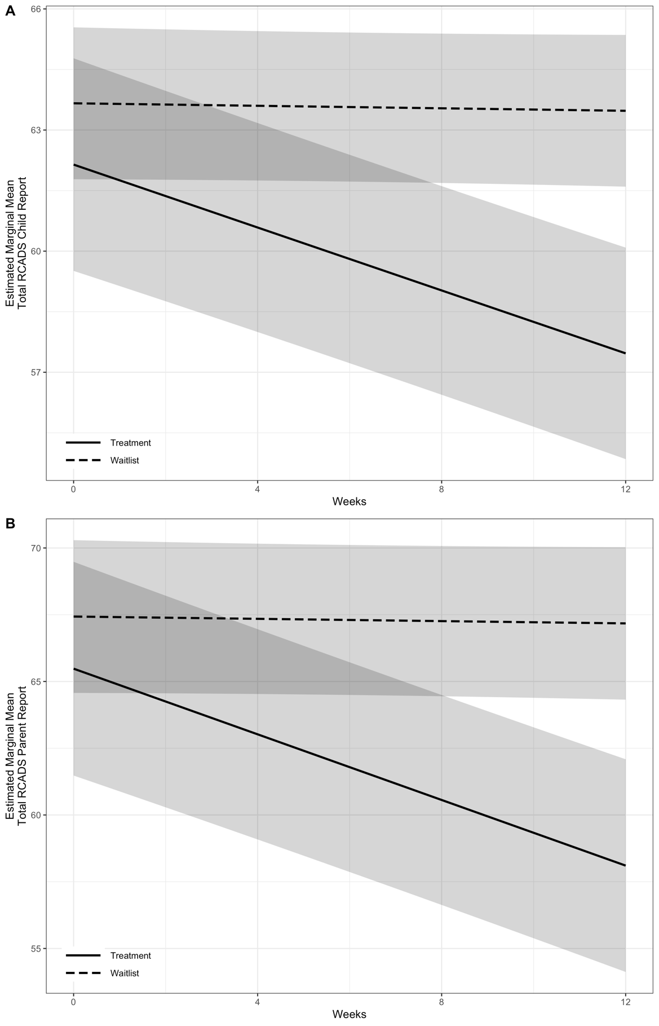
Figure 2. Estimated marginal means and confidence intervals from the models for A) RCADS (Revised Children’s Anxiety and Depression Scale) – Child report and B) RCADS – Parent report

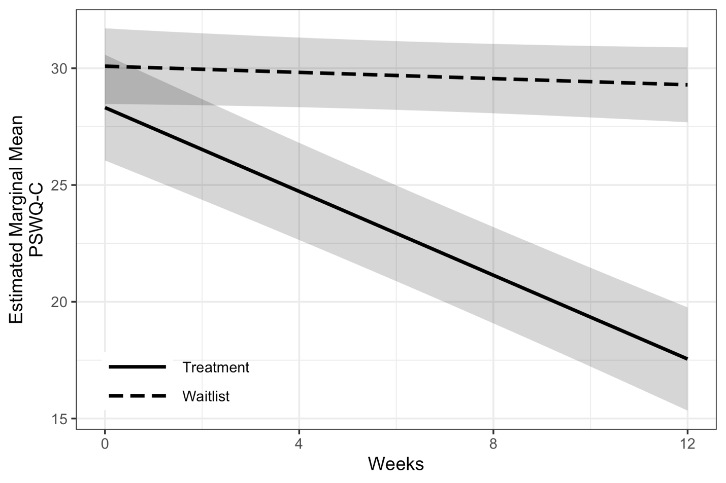 Figure 3. Estimated marginal means and confidence intervals from the model for the Penn State Worry Questionnaire – child version.

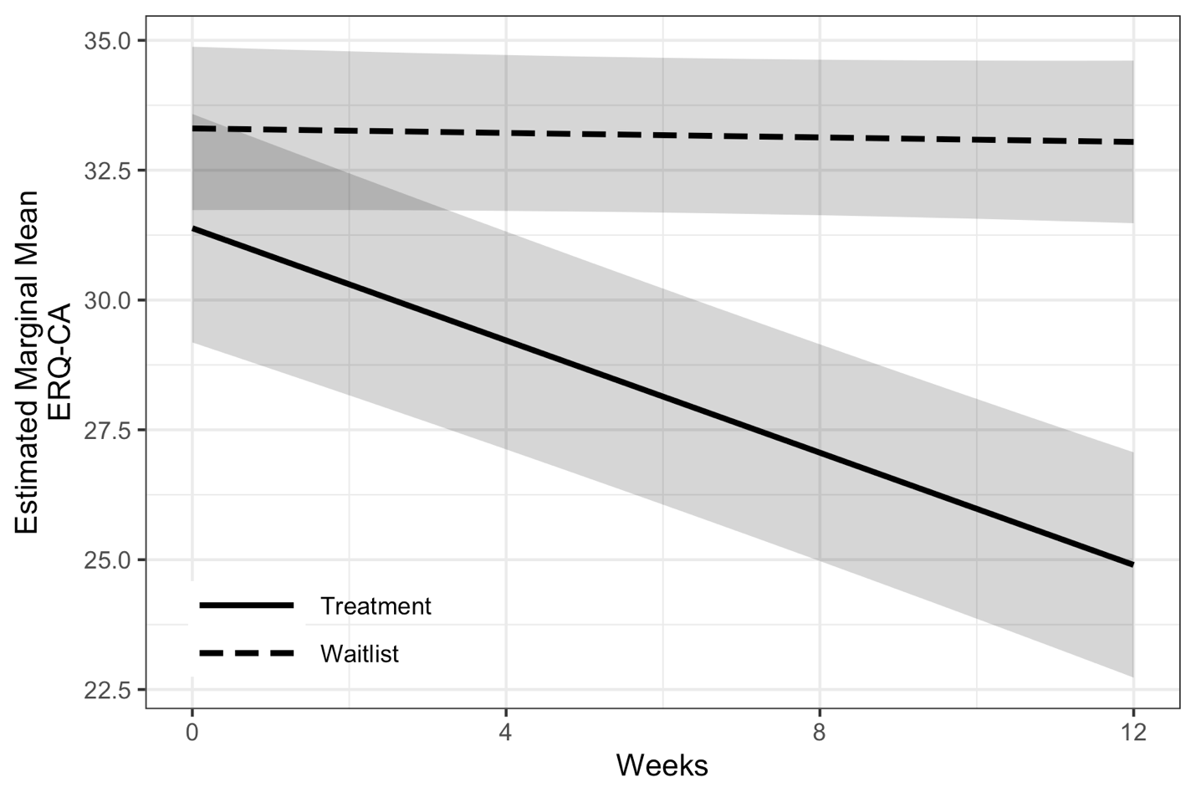
Figure 4. Estimated marginal means and confidence intervals from the model for the Emotion Regulation Questionnaire for Children and Adolescents.

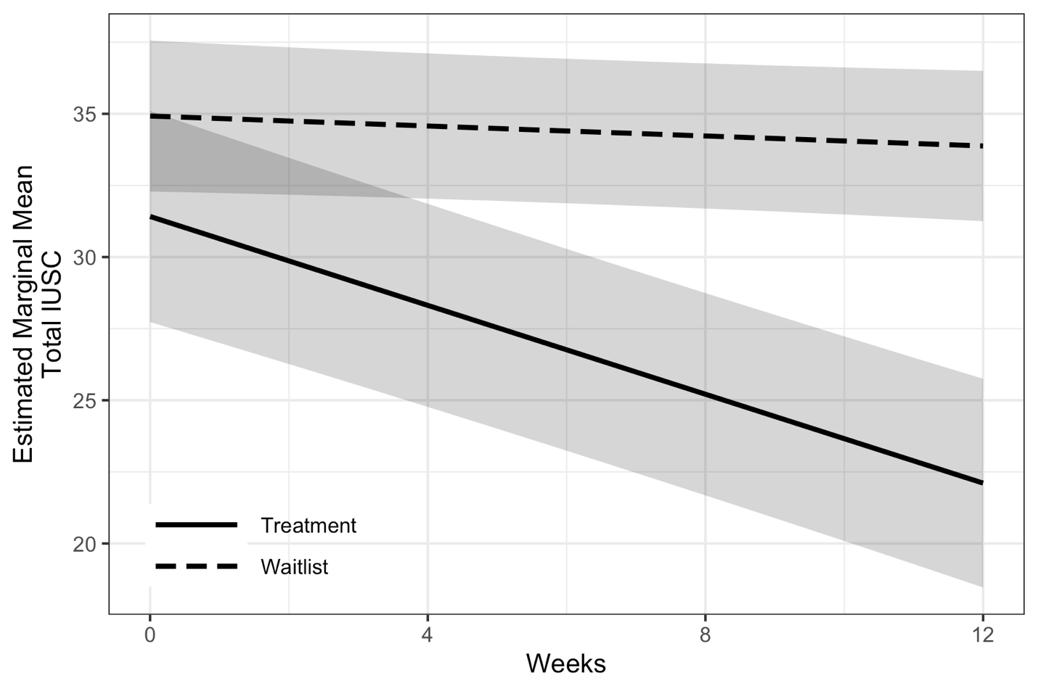
Figure 5. Estimated marginal means and confidence intervals from the model for the total Intolerance of Uncertainty Scale for Children.

